Ulysses S. Grant Snap Chat
DIRECTIONS: Create Snapchat Filter that shows Ulysses S. Grant as either the unlikely hero or a failure. You can use the outline of a person below start your filter. You should draw in his eyebrows and mouth to show his emotion at being a hero or a failure as well as images around him that show why he feels like a hero or a failure. You child can add color if you would like.
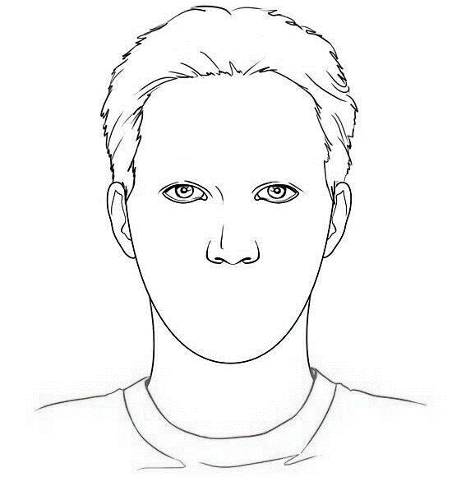

DIRECTIONS: In a paragraph of 7-10 sentences, explain what you drew and how it supports Grant being an unlikely hero or failure.

