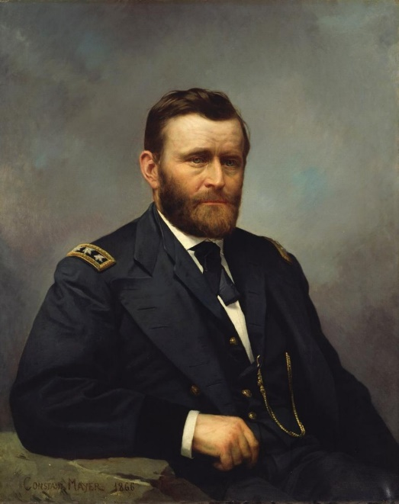
Ulysses S. Grant
Introduction
Ask you child to list what makes a person a hero. You can discuss what they suggest and, if you choose, point out some other characteristics that they may not have mentioned.
Your child may mention things about superheroes like Captain America or Superman. If this happens, you can prompt them to think about what makes these people heroes other than their superstrength or other magical abilities. They should then tell you things like courage, the willingness to do the right thing, etc. You can use this a transition into our learning about Ulysses S. Grant, who some people thought would never become somebody but who many believe to be a national hero.

Video Activity
While your child watches Gary Adelman: Ulysses S. Grant, the Unlikely Hero from History Channel’s History at Home series, have them take notes in a T-chart like the one below about what makes Grant a hero and what makes him a failure. They can create this on a piece of paper or on a PowerPoint slide.
Hero | Failure

Post Video Activity Options
- Have your child write a response to Gary Adelman’s claim that Ulysses S. Grant is an unlikely hero. They should use evidence from their T-chart to explain why they either agree or disagree with Adelman.
  - A different option might be to have your child verbally explain whether they agree or disagree with Adelman instead of writing about it.
- Your child can learn more about important Civil War battles that Ulysses S. Grant was a part of by checking out this Interactive Map of His Key Civil War Battles from History.com. They can scroll along the left side to read about the battles in order or they can click on the white circles on the map and a pop up will open on the right opens so they can read more about the battle.
  - You might then have your child choose a battle they think is the most important and explain why they feel that way.
  - As an extension, you could have your child do more research on the battle to create a museum exhibit entry on a PowerPoint slide that includes the following:
    - The date of the battle
    - Which side won the battle
    - A short summary of the key points of the battle
    - A map or image of the battle
- Ask your child to create Snapchat Filter that shows Ulysses S. Grant as either the unlikely hero or a failure. You can use the outline of a person on the last page for your student to start their filter. They should draw in his eyebrows and mouth to show his emotion at being a hero or a failure as well as images around him that show why he feels like a hero or a failure. If you so choose, your child can color their Snapchat Filter of Grant.
  - To extend their literacy skills, you could have your child write about the images they chose explaining what the images are and how they show Ulysses S. Grant as a hero or failure. If you prefer instead, you could have your child verbally explain it to you.
