Cov Peb Tug Bs: Qib 3–5

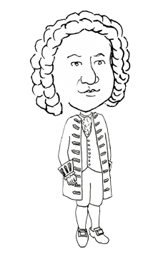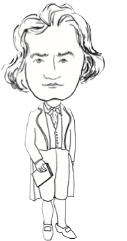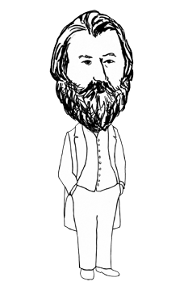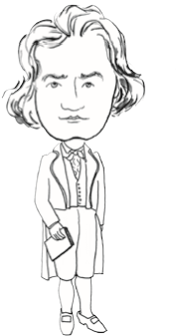
© 2013 Handwritin
g
Witho
u
t Tears
®

e
Nam
:
Bach
March 31, 1685
Beethoven
December 16, 1770
Brahms
May 7, 1833
© 2013 Handwritin
g
Witho
u
t Tears
®

Name:
Bach
March 31, 1685
Beethoven
December 16, 1770
Brahms
May 7, 1833
Lub hom phiaj:
- Xyaum kev txawj sau ntawv
- Kawm txog cov kws sau nkauj uas muaj npe
Cov Ntaub Ntawv:
- 3 tus Bs rub tawm (download)
- Xaum sau (pencils)
- Xaum xim (Crayons)
Kev Ua Si
- Qhia Ua Ntej txog Peb tug Bs: Bach, Beethoven, thiab Brahms.
Piav rau cov me nyuam tias muaj peb tug sau ntawv hauv lawv daim ntawv. Ib tug yog Bach, ib tug yog Beethoven, thiab ib tug yog Brahms. Siv sijhawm los kawm txog peb qhov kev sau nkauj thiab tsim cov suab nkauj tawm ntawm lawv cov nkauj. Qhov internet thiab koj cov chaw qiv ntawv hauv zos yog qhov chaw zoo kom tau txais cov ntaub ntawv thiab cov nkauj!

- Sau txog cov kws sau ntawv.
Ua qauv rau cov npe ntawm cov nkauj thiab cov kws tso rau ntawm lub rooj tsavxwm hauv kev sau ntawv. Kom cov me nyuam sau txog lawv cov nkauj uas lawv nyiam los ntawm cov kws sau nkauj. Yog tias koj ua kom muaj cov nkauj nyob hauv koj chav kawm, nug kom lawv qhia dab tsi lawv tuaj yeem ua si thiab qhia lawv cov kev paub dhau los ntawm cov kws sau nkauj no. Saib xyuas menyuam thaum lawv sau thiab nco ntsoov ua qauv thiab ntxias dag cov kev sib txuas ntawm lub rooj tsavxwm.
- Tham xim daim duab.
Kom cov me nyuam thas xim rau hauv cov duab ntawm cov kws sau nkauj nrov thiab ua si ib co nkauj hauv koj chav kawm.
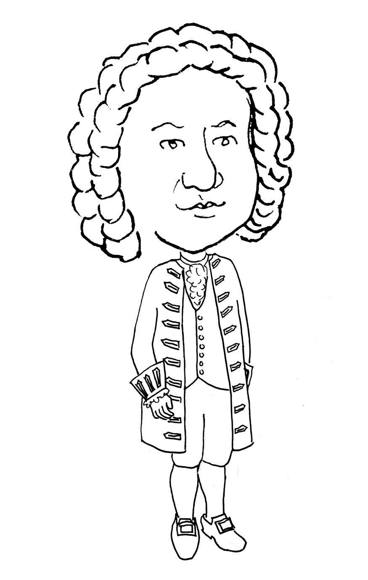
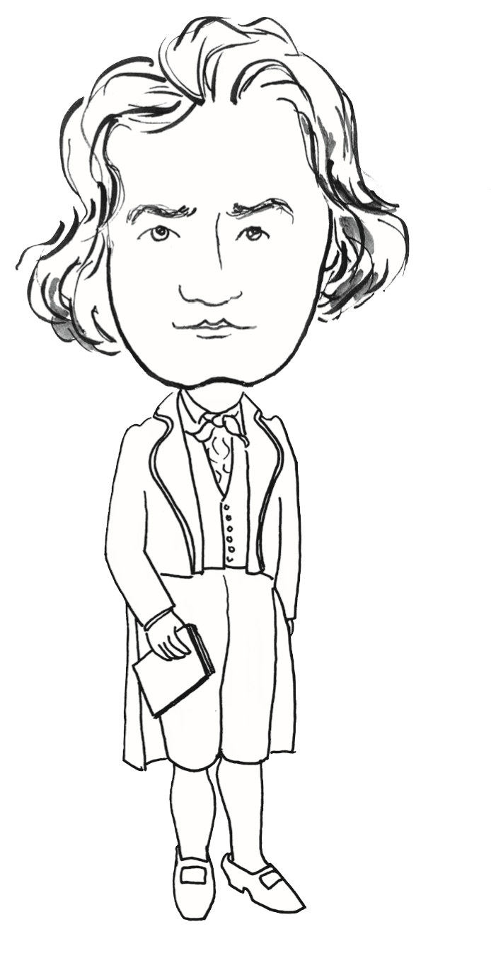
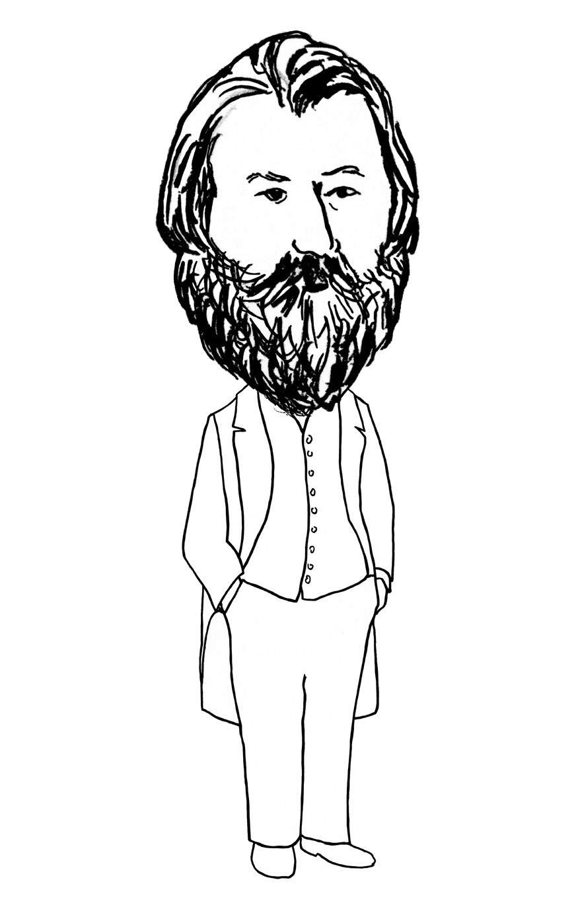
:
Bach
March 31, 1685
Beethoven
December 16, 1770
Brahms
May 7, 1833
Name:
Bach
March 31, 1685
Beethoven
December 16, 1770
Brahms
May 7, 1833

