Theodore Roosevelt & the Teddy Bear
Introduction:
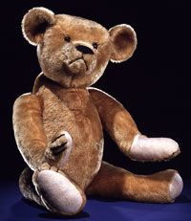
Show your child a picture of a teddy bear like the one below and ask them why they think it is called a “teddy” bear?
Your child may respond with answers like “I don’t know” or “I’ve never thought about it.” If they respond with one of these answers, you might tell them that there are many things we don’t know until we ask questions like this and decide to do a little digging (research) to find the answer.
Your child might also suggest that the teddy bear was names after a famous person or bear named Teddy. If so, they are on the right track and will learn more about that person and bear during the video!

Video:
Play the video, Dan Abrams: How Teddy Roosevelt Inspired the Teddy Bear, from the History Channel: History at Home by clicking on the hyperlink above.
While your child watches the video, ask them to listen for the story of how Theodore Roosevelt inspired the creation of the stuffed teddy bear toy and be prepared to retell the story after the video is done.

Activity Options:
After the video, you can have your child do one or both of the following:
- verbally retell you the story of how the teddy bear got its name in their own words.
- create a cartoon or comic strip showing the story of how Theodore Roosevelt inspired the creation of the teddy bear.
You can also choose one or both of the suggested activities from History at Home:
- Activity #1: Exercise Like Roosevelt in which your child creates a “walk around” exercise activity in Theodore Roosevelt fashion. (See History at Home - Teddy Roosevelt Activities Handout.)

- Activity #2: Family Dinner in which your child creates a list of questions and conversation topics for a family talk at dinner. (See History at Home - Teddy Roosevelt Activities Handout)

