Theodore Roosevelt:
Trustbuster, Rough Rider, accidental President?
Introduction:
Show your child a picture of Mount Rushmore like the one below and ask them to name the presidents they see there. You child should be able to recognize President George Washington (far left), President Thomas Jefferson (next to Washington), and President Abraham Lincoln (far right). They might be less familiar with President Theodore Roosevelt (between Jefferson and Lincoln). If they can name him by sight, ask your child what they can tell you about Roosevelt and where they learned about him. If they cannot recognize him by sight, tell them that it is President Theodore Roosevelt, the person whom Roosevelt High School is named after here in Fresno, and that they will learn more about him today.
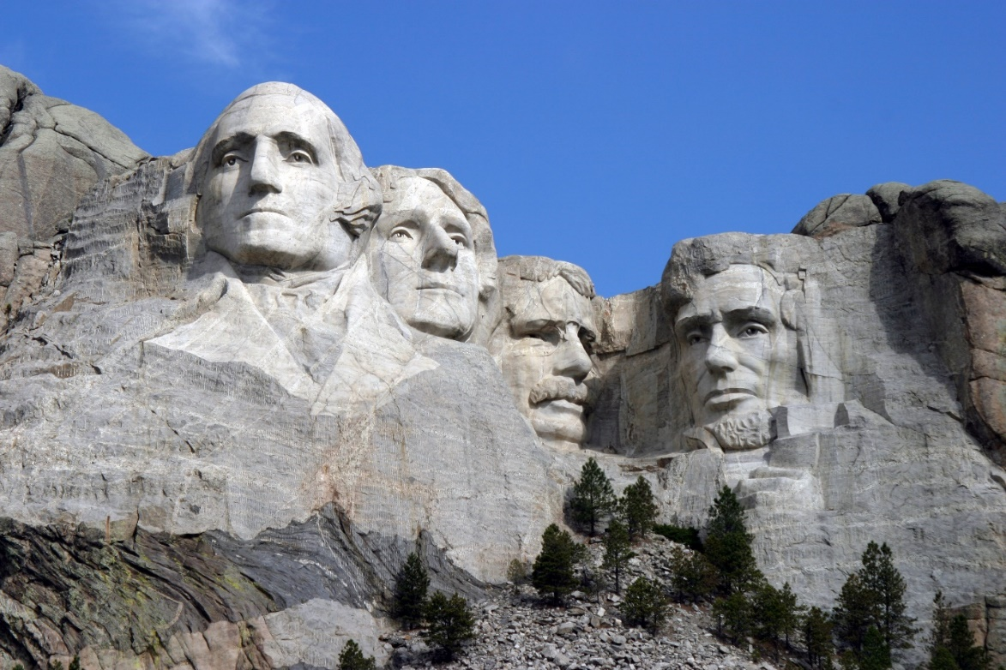
Reading Activity Option:
Have your child read the Kids National Geographic: Theodore Roosevelt article on their website taking note about what made him an extraordinary president as well as an “accidental” president.

Video Activity Option:
Have your child watch Dan Abrams: How Teddy Roosevelt Inspired the Teddy Bear from the History Channel: History at Home by clicking on the hyperlink above. While they watch the video, have your child take notes about Roosevelt’s accomplishments on their computer or on a separate sheet of paper.

After the Reading or Video Option:
- Ask your child to explain to you how Theodore Roosevelt was an “accidental” president and the most important thing he did during his life (either while a soldier or while President). You might also consider having your child explain their reasoning why that is the most important thing Roosevelt did.
- Have your child create a poster advertising an exhibit about Theodore Roosevelt. The poster should include an eye-catching image and a phrase trying to interest people to come to the exhibit about Roosevelt.
- Have your child create a PowerPoint presentation about 2 of the national parks and/or national monuments established by Theodore Roosevelt such as Yosemite National Park and Muir Woods. This National Parks website can be used to help complete the research for the PowerPoint. Their PowerPoint should include the some of the following information:
  - When the park was established
  - Where the park is located
  - A map of the park
  - Any features that make the park special like Balconies Cave at Pinnacles, a national monument in California.

