Ancient Egypt Mummification
Introduction
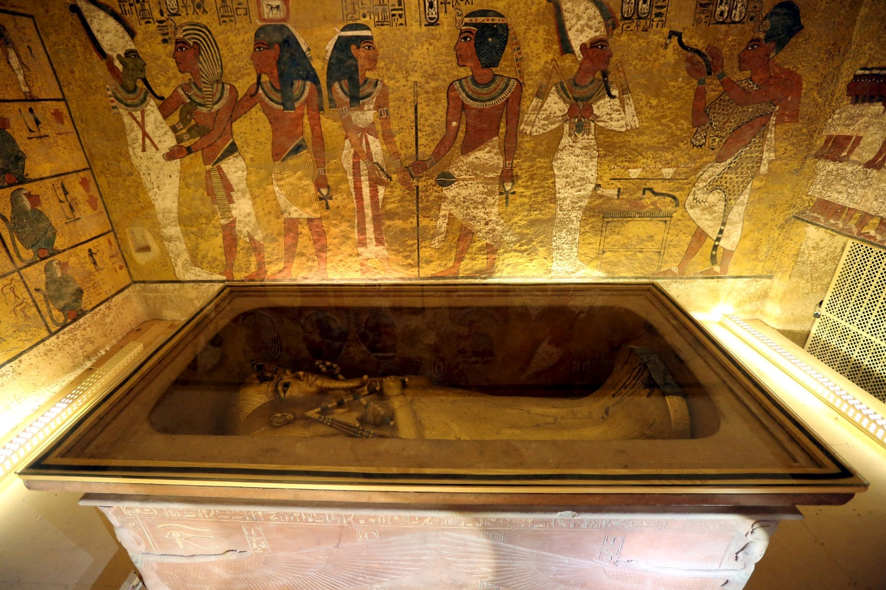
Show your child this image of King Tutankhamun’s tomb and ask them the following questions:
- What do you see?
  - You can prompt your child to look closer by asking them specifically what people, things, and actions they see.
  - They might say things like, “I see 7 people,” “I see a box with a statue in it,” “There is something written on the wall,” etc.
    - HINT: Do not tell them yet that this is King Tut’s tomb, the “statue” is a sarcophagus (coffin), or that those are hieroglyphs on the wall. The purpose behind this is to get your child to look deeply at the image to engage their curiosity and begin to create questions about what they see.
- What do you think this is?
  - Your child might say something like this is a museum or that there is graffiti on the walls. They may also predict that this is burial chamber.
  - When your child makes a hypothesis about what this is, ask them, “What makes you say that?” or “What evidence from the picture supports, or helps prove, what you think this is?” Asking your child this follow up question helps them learn to use evidence and reasoning to support a claim.
- What do you wonder about? (What questions do you have? What questions could you create about this image?)
  - Your child might ask questions like “What does the writing say on the wall?” or “I wonder who the statue is of?” If they had early guessed that this was a burial chamber or tomb, they may ask questions about who is buried in the tomb.
  - The purpose of asking your child to create questions is to encourage them to wonder about things and to then use those questions as a starting point for other research and activities – like more learning about hieroglyphs (see Elementary Ancient Egypt Hieroglyphs lesson).
Activity
After examining the image, you can tell your child that the picture if of King Tut’s tomb, the burial place of the boy pharaoh, King Tutankhamun of Egypt. His was the first intact tomb that archeologists have been able to explore, which gave the world many details about how the pharaohs (kings) of Egypt were buried – including their mummification.
- Have your child watch this TedEd video about mummification: TedEd: Mummification. This cartoon video goes into detail about how mummies were created like how they removed the brain and other organs from the body. You might consider previewing the video before showing it to you child to determine if you think it is appropriate for their viewing.
- Next have your child engage in University of Manchester: Making a Mummy in which they get to learn more about and participate in a cartoon version of mummification and then take a quiz about the process. You might consider previewing the activity as you did with the above TedEd to gauge how comfortable your child may be with the simulation.
Extension Opportunities
- Learn more about King Tutankhamun to create a short biography PowerPoint or poster about him. The poster can be done on a sheet of paper, a PowerPoint slide, or a Google Drawing.
- Research more about the pyramids by reading this History.com Egyptian Pyramids article.
- Create a museum poster advertising an exhibit about Howard Carter’s discovery of King Tut’s tomb. On the poster, it should list and show some things that people would see and learn about in the exhibit. This can be done on a sheet of paper, a PowerPoint slide, or a Google Drawing.
  - Resources:
    - Vimeo tour of the tomb
    - Howard Carter’s discovery and the Curse of Tut’s Tomb
