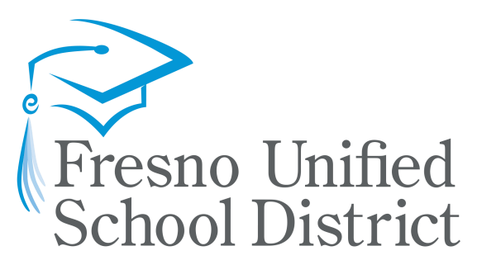

Pom Zoo Nyeem Cov Phau Ntawv

Kindergarten
-

Qib 2

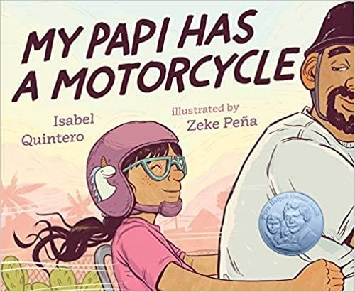 | When Daisy Ramona zooms around her neighborhood with her papi on his motorcycle, she sees the people and places she's always known. She also sees a community that is rapidly changing around her. But as the sun sets purpleblue-gold behind Daisy Ramona and her papi, she knows that the love she feels will always be there. With vivid illustrations and text bursting with heart, My Papi Has a Motorcycle is a young girl's love letter to her hardworking dad and to memories of home that we hold close in the midst of change.  Available in print, ebook, and audio format at the Fresno County Public Library  Muaj cov ntawv luam tawm, ebook, thiab cov suab nyob ntawm Fresno County Public Library
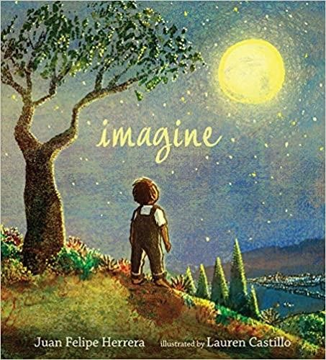 | A buoyant, breathtaking poem from Juan Felipe Herrera — brilliantly illustrated by Caldecott Honoree Lauren Castillo — speaks to every dreaming heart.  Have you ever imagined what you might be when you grow up? When he was very young, Juan Felipe Herrera picked chamomile flowers in windy fields and let tadpoles swim across his hands in a creek. He slept outside and learned to say good-bye to his amiguitos each time his family moved to a new town. He went to school and taught himself to read and write English and filled paper pads with rivers of ink as he walked down the street after school. And when he grew up, he became the United States Poet Laureate and read his poems aloud on the steps of the Library of Congress. If he could do all of that . . . what could you do?  Available in print and audio format at the Fresno County Public Library  Muaj cov ntawv luam tawm thiab suab ua qauv nyob rau ntawm Fresno County Public Library
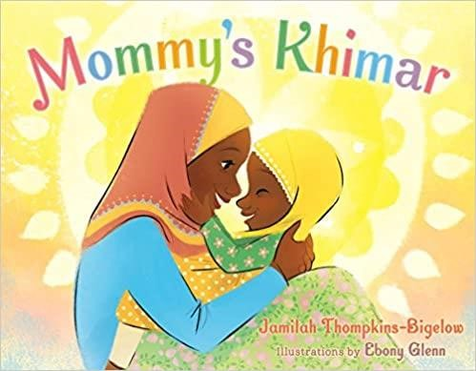 | Selected as a Best Book of 2018 by NPR, Kirkus Reviews, School Library Journal, and Shelf Awareness.  A young Muslim girl plays dress up with her mother's headscarves, feeling her mother's love with every one she tries on. Charming and vibrant illustrations showcase the beauty of the diverse and welcoming community in this portrait of a young Muslim American girl's life.  Available in print at the Fresno County Public Library  Muaj cov ntawv luam tawm hauv Fresno County Chaw Qiv Ntawv

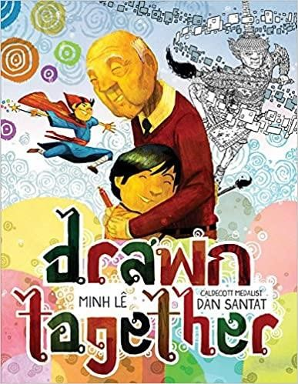 | When a young boy visits his grandfather, their lack of a common language leads to confusion, frustration, and silence. But as they sit down to draw together, something magical happens-with a shared love of art and storytelling, the two form a bond that goes beyond words.  With spare, direct text by Minh Lê and luminous illustrations by Caldecott Medalist Dan Santat, this stirring picture book about reaching across barriers will be cherished for years to come.  Available in print and ebook format at the Fresno County Public Library  Muaj cov ntawv luam tawm, ebook, thiab cov suab nyob ntawm Fresno County Public Library
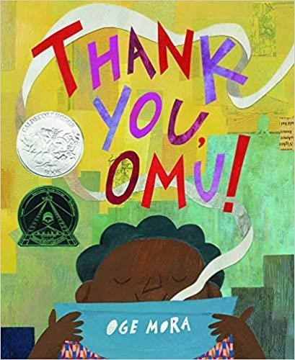 | Everyone in the neighborhood dreams of a taste of Omu's delicious stew! One by one, they follow their noses toward the scrumptious scent. And one by one, Omu offers a portion of her meal. Soon the pot is empty. Has she been so generous that she has nothing left for herself?  Debut author-illustrator Oge Mora brings to life a heartwarming story of sharing and community in colorful cut-paper designs as luscious as Omu's stew, with an extra serving of love. An author's note explains that "Omu" (pronounced AH-moo) means "queen" in the Igbo language of her parents, but growing up, she used it to mean "Grandma." This book was inspired by the strong female role models in Oge Mora's life.  Available in print and ebook format at the Fresno County Public Library  Muaj cov ntawv luam tawm, ebook, thiab cov suab nyob ntawm Fresno County Public Library
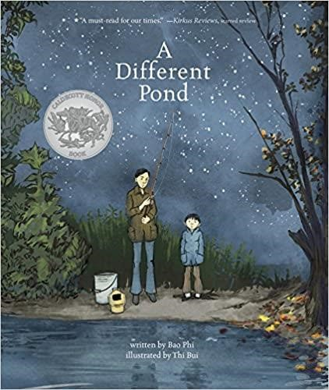 | 2018 Caldecott Honor Book  A Different Pond is an unforgettable story about a simple event - a long-ago fishing trip. Graphic novelist Thi Bui and acclaimed poet Bao Phi deliver a powerful, honest glimpse into a relationship between father and son - and between cultures, old and new. As a young boy, Bao and his father awoke early, hours before his father's long workday began, to fish on the shores of a small pond in Minneapolis. Unlike many other anglers, Bao and his father fished for food, not recreation. A successful catch meant a fed family. Between hopefilled casts, Bao's father told him about a different pond in their homeland of Vietnam. Thi Bui's striking, evocative art paired with Phi's expertly crafted prose has earned this powerful picture book’s six starred reviews and numerous awards.  Available in print, ebook, and audio formats at the Fresno County Public Library  Muaj cov ntawv luam tawm, ebook, thiab cov suab nyob ntawm Fresno County Public Library

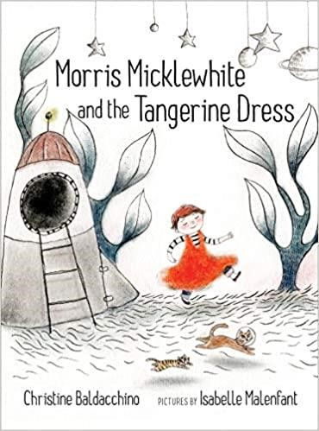 | Morris is a little boy who loves using his imagination. But most of all, Morris loves wearing the tangerine dress in his classroom’s dress-up center. The children in Morris’s class don’t understand. Dresses, they say, are for girls. And Morris certainly isn’t welcome in the spaceship some of his classmates are building. Astronauts, they say, don’t wear dresses. One day when Morris feels all alone and sick from their taunts, his mother lets him stay home from school. Morris dreams of a fantastic space adventure with his cat, Moo. Inspired by his dream, Morris paints the incredible scene he saw and brings it with him to school. He builds his own spaceship, hangs his painting on the front of it and takes two of his classmates on an outer space adventure. With warm, dreamy illustrations, Isabelle Malenfant perfectly captures Morris’s vulnerability and the vibrancy of his imagination.  Available in print at the Fresno County Public Library  Muaj cov ntawv luam tawm hauv Fresno County Chaw Qiv Ntawv
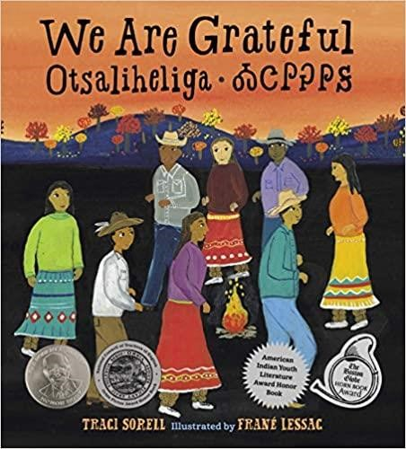 | The Cherokee community is grateful for blessings and challenges that each season brings. This is modern Native American life as told by an enrolled citizen of the Cherokee Nation.  The word otsaliheliga (oh-jah-LEE-hay-lee-gah) is used by members of the Cherokee Nation to express gratitude. Beginning in the fall with the new year and ending in summer, follow a full Cherokee year of celebrations and experiences. Written by a citizen of the Cherokee Nation, this look at one group of Native Americans is appended with a glossary and the complete Cherokee syllabary, originally created by Sequoyah.  Available in print at the Fresno County Public Library  Muaj cov ntawv luam tawm hauv Fresno County Chaw Qiv Ntawv
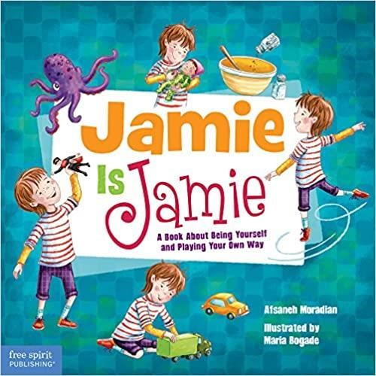 | When free-spirited Jamie arrives at a new preschool, all the kids learn that it’s okay to play whatever you want.  There are so many fun things to play with at Jamie’s new preschool— baby dolls to care for, toy cars to drive—and Jamie wants to play with them all! But the other children are confused . . . is Jamie a boy or a girl? Some toys are just for girls and others are just for boys, aren’t they? Not according to Jamie! This book challenges gender stereotypes, shows readers that playing is fundamental to learning, and reinforces the idea that all chil-dren need the freedom to play unencumbered. A special section for teachers, parents, and care­givers provides tips on how to make children’s playtime learning time.  Available in print at the Fresno County Public Library  Muaj cov ntawv luam tawm hauv Fresno County Chaw Qiv Ntawv

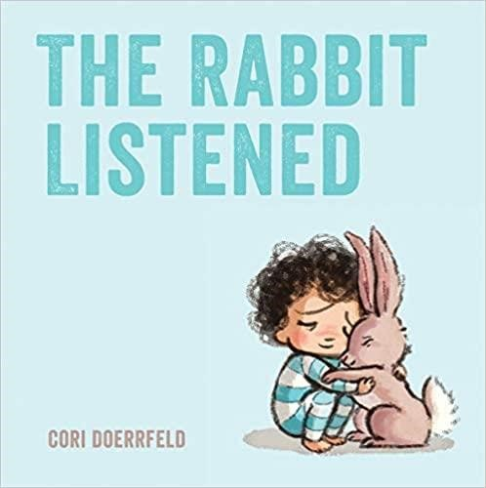 | When something sad happens, Taylor doesn't know where to turn. All the animals are sure they have the answer. The chicken wants to talk it out, but Taylor doesn't feel like chatting. The bear thinks Taylor should get angry, but that's not quite right either. One by one, the animals try to tell Taylor how to act, and one by one they fail to offer comfort. Then the rabbit arrives. All the rabbit does is listen . . . which is just what Taylor needs.  With its spare, poignant text and irresistibly sweet illustration, The Rabbit Listened is about how to comfort and heal the people in your life, by taking the time to carefully, lovingly, gently listen.  Available in print and ebook format at the Fresno County Public Library  Muaj cov ntawv luam tawm, ebook, thiab cov suab nyob ntawm Fresno County Public Library
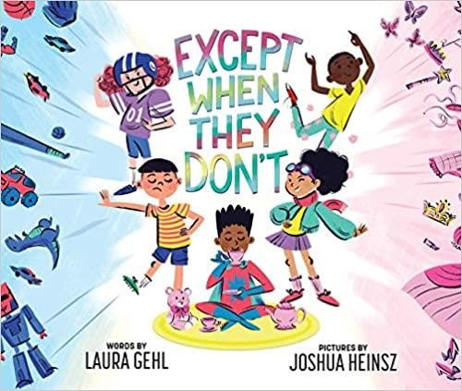 | Children are often told by many different people about what toys they're supposed to play with, what interests they should have, and who they should be simply because of their gender. This stereotype-breaking book invites children to examine what they're told "boy" and "girl" activities are and encourages them to play with whatever they want to and to be exactly who they are! This book is published in partnership with GLAAD to accelerate LGBTQ inclusivity and acceptance.  Available in print at the Fresno County Public Library  Muaj cov ntawv luam tawm hauv Fresno County Chaw Qiv Ntawv
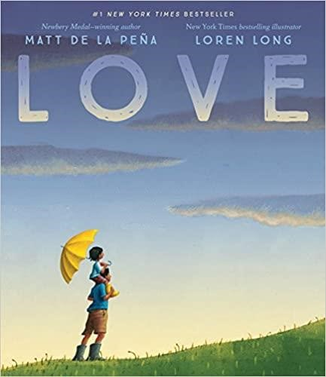 | New York Times bestseller  In this heartfelt celebration of love, Newbery Medal-winning author Matt de la Peña and bestselling illustrator Loren Long depict the many ways we experience this universal bond, which carries us from the day we are born throughout the years of our childhood and beyond. With a lyrical text that's soothing and inspiring, this tender tale is a needed comfort and a new classic that will resonate with readers of every age.  Available in print, ebook, and audio format at the Fresno County Public Library  Muaj cov ntawv luam tawm, ebook, thiab cov suab nyob ntawm Fresno County Public Library
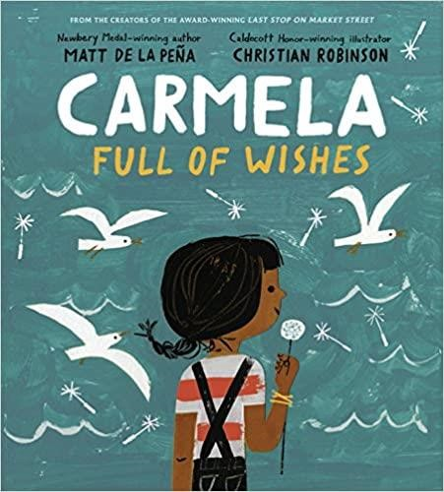 | When Carmela wakes up on her birthday, her wish has already come true-she's finally old enough to join her big brother as he does the family errands. Together, they travel through their neighborhood, past the crowded bus stop, the fenced-off repair shop, and the panadería, until they arrive at the  Laundromat, where Carmela finds a lone dandelion growing in the pavement. But before she can blow its white fluff away, her brother tells her she has to make a wish. If only she can think of just the right wish to make . . .  With lyrical, stirring text and stunning, evocative artwork, Matt de la Peña and Christian Robinson have crafted a moving ode to family, to dreamers, and to finding hope in the most unexpected places.  Available in print and audio format at the Fresno County Public Library  Muaj cov ntawv luam tawm thiab suab ua qauv nyob rau ntawm Fresno County Public Library

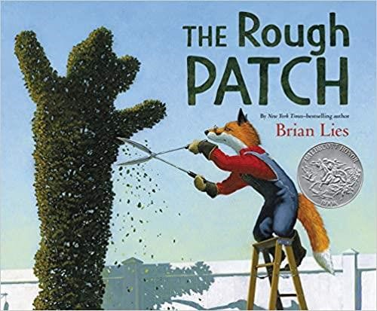 | A Caldecott Honor Book; ALA Notable Book  New York Times–bestselling author-illustrator Brian Lies has created a beautiful, accessible, and deeply personal story about friendship, loss, and renewal. Evan and his dog do everything together, from eating ice cream to caring for their prize-winning garden, which grows big and beautiful. One day the unthinkable happens: Evan’s dog dies. Heartbroken, Evan destroys the garden and everything in it. The ground becomes overgrown with prickly weeds and thorns, and Evan embraces the chaos. But beauty grows in the darkest of places, and when a twisting vine turns into an immense pumpkin, Evan is drawn out of his isolation and back to the county fair, where friendships—old and new—await.  Available in print and audio format at the Fresno County Public Library  Muaj cov ntawv luam tawm thiab suab ua qauv nyob rau ntawm Fresno County Public Library
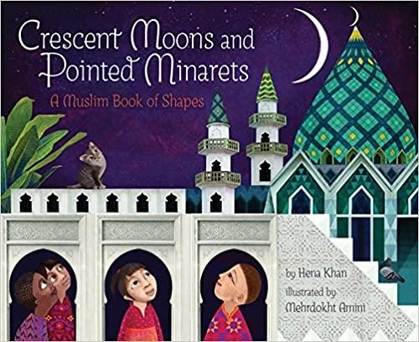 | Toddler book of shapes and Islamic traditions: From a crescent moon to a square garden to an octagonal fountain, this breathtaking picture book celebrates the shapes-and traditions-of the Muslim world. Sure to inspire questions and observations about world religions and cultures, Crescent Moons and Pointed Minarets is equally at home in a classroom reading circle and on a parent's lap being read to a child.  Available in print at the Fresno County Public Library  Muaj cov ntawv luam tawm hauv Fresno County Chaw Qiv Ntawv
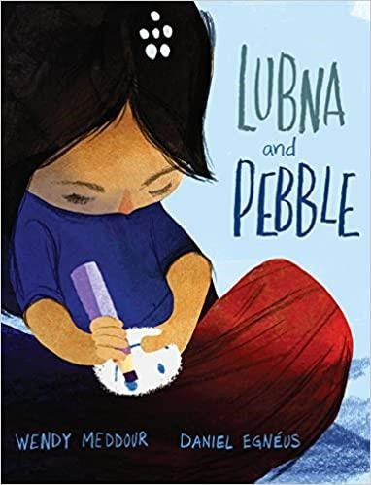 | Time Magazine "10 Best YA and Children's Books of 2019" selection; New York Public Library's Best Books for Kids 2019 selection; Chicago Public Library's Best of the Best Books 2019 selection  In an unforgettable story that subtly addresses the refugee crisis, a young girl must decide if friendship means giving up the one item that brings her comfort during a time of utter uncertainty.  Lubna's best friend is a pebble. Pebble always listens to her stories. Pebble always smiles when she feels scared. But when a lost little boy arrives in the  World of Tents, Lubna realizes that he needs Pebble even more than she does.  This emotionally stirring and stunningly illustrated picture book explores one girl's powerful act of friendship in the midst of an unknown situation.  Available in print at the Fresno County Public Library  Muaj cov ntawv luam tawm hauv Fresno County Chaw Qiv Ntawv
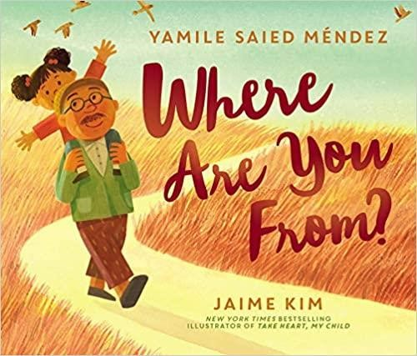 | This resonant and award-winning picture book tells the story of one girl who constantly gets asked a simple question that doesn’t have a simple answer.  When a girl is asked where she’s from—where she’s really from—none of her answers seems to be the right one. Unsure about how to reply, she turns to her loving abuelo for help. He doesn’t give her the response she expects. She gets an even better one.  Available in print and audio format at the Fresno County Public Library  Muaj cov ntawv luam tawm thiab suab ua qauv nyob rau ntawm Fresno County Public Library

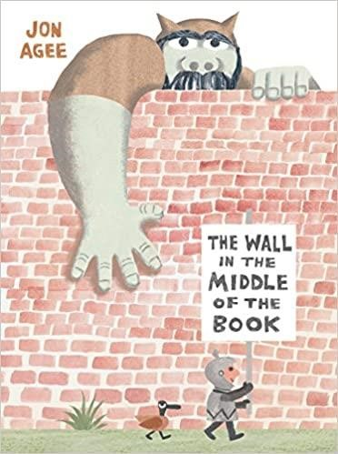 | There's a wall in the middle of the book, and our hero--a young knight--is sure that the wall protects his side of the book from the dangers of the other side-like an angry tiger and giant rhino, and worst of all, an ogre who would gobble him up in a second! But our knight doesn't seem to notice the crocodile and growing sea of water that are emerging on his side. When he's almost over his head and calling for help, who will come to his rescue? An individual who isn't as dangerous as the knight thought--from a side of the book that might just have some positive things to offer after all!  Available in print at the Fresno County Public Library  Muaj cov ntawv luam tawm hauv Fresno County Chaw Qiv Ntawv
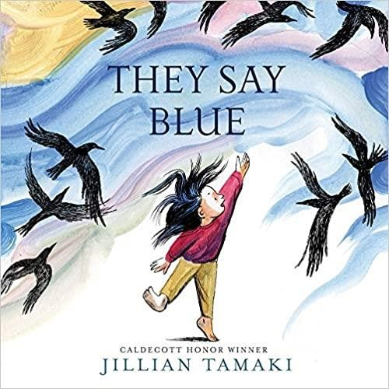 | A 2018 Boston Globe-Horn Book Picture Book Award Winner; 2018 Parent's Choice Picture Book Gold Award Winner  In captivating paintings full of movement and transformation, Tamaki follows a young girl through a year or a day as she examines the colors in the world around her. Egg yolks are sunny orange as expected, yet water cupped in her hands isn’t blue like they say. But maybe a blue whale is blue. She doesn’t know, she hasn’t seen one. Playful and philosophical, They Say Blue is a book about color as well as perspective, about the things we can see and the things we can only wonder at.  Available in print and ebook format at the Fresno County Public Library  Muaj cov ntawv luam tawm, ebook, thiab cov suab nyob ntawm Fresno County Public Library
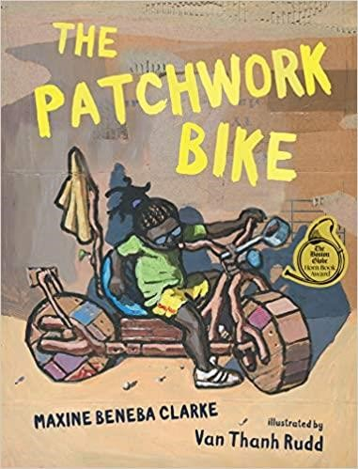 | When you live in a village at the edge of the no-go desert, you need to make your own fun. That's when you and your brothers get inventive and build a bike from scratch, using everyday items like an old milk pot (maybe Mum is still using it, maybe not) and a used flour sack. You can even make a license plate from bark if you want. The end result is a spectacular bike, perfect for whooping and laughing as you bumpety bump over sand hills, past your fedup mum and right through your mud-for-walls home. A joyous story by multiaward-winning author Maxine Beneba Clarke, beautifully illustrated by street artist Van Thanh Rudd.  Available in print at the Fresno County Public Library  Muaj cov ntawv luam tawm hauv Fresno County Chaw Qiv Ntawv

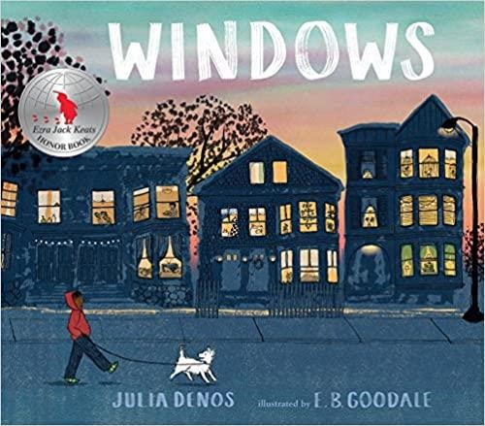 | Before your city goes to sleep, you might head out for a walk, your dog at your side as you go out the door and into the almost-night. Anything can happen on such a walk: you might pass a cat, or a friend, or even an early raccoon. And as you go down your street and around the corner, the windows around you light up one by one until you are walking through a maze of paper lanterns, each one granting you a brief, glowing snapshot of your neighbors as families come together and folks settle in for the night. With a setting that feels both specific and universal and a story full of homages to The Snowy Day, Julia Denos and E. B. Goodale have created a singular book — at once about the idea of home and the magic of curiosity, but also about how a sense of safety and belonging is something to which every child is entitled.  Available in print at the Fresno County Public Library  Muaj cov ntawv luam tawm hauv Fresno County Chaw Qiv Ntawv
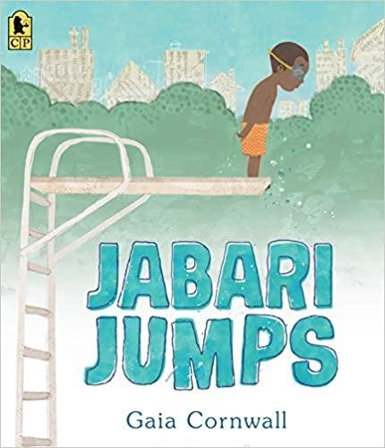 | Jabari is definitely ready to jump off the diving board. He’s finished his swimming lessons and passed his swim test, and he’s a great jumper, so he’s not scared at all. “Looks easy,” says Jabari, watching the other kids take their turns. But when his dad squeezes his hand, Jabari squeezes back. He needs to figure out what kind of special jump to do anyway, and he should probably do some stretches before climbing up onto the diving board. In a sweetly appealing tale of overcoming your fears, Gaia Cornwall captures a moment between a patient and encouraging father and a determined little boy you can’t help but root for.  Available in print and audio format at the Fresno County Public Library  Muaj cov ntawv luam tawm thiab suab ua qauv nyob rau ntawm Fresno County Public Library
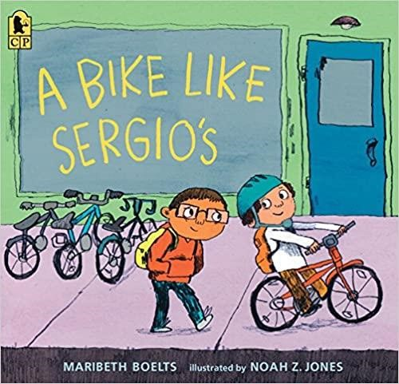 | Ruben feels like he is the only kid without a bike. His friend Sergio reminds him that his birthday is coming, but Ruben knows that the kinds of birthday gifts he and Sergio receive are not the same. After all, when Ruben’s mom sends him to Sonny’s corner store for groceries, sometimes she doesn’t have enough money for everything on the list. So when Ruben sees a dollar bill fall out of someone’s purse, he picks it up and puts it in his pocket. But when he gets home, he discovers it’s not one dollar or even five or ten—it’s a hundred-dollar bill, more than enough for a new bike just like Sergio’s! But what about the crossed-off groceries? And what about the woman who lost her money?  Available in print at the Fresno County Public Library  Muaj cov ntawv luam tawm hauv Fresno County Chaw Qiv Ntawv

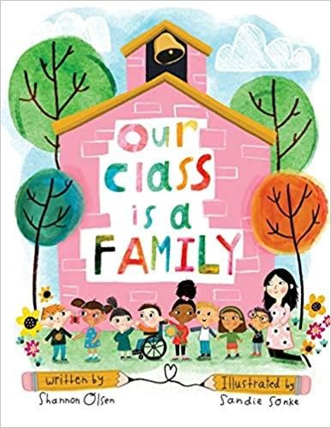 | Teachers do so much more than just teach academics. They build a sense of community within their classrooms, creating a home away from home where they make their students feel safe, included, and loved.  With its heartfelt message and colorfully whimsical illustrations, “Our Class is a Family” is a book that will help build and strengthen that class community. Kids learn that their classroom is a place where it’s safe to be themselves, it’s okay to make mistakes, and it’s important to be a friend to others. When hearing this story being read aloud by their teacher, students are sure to feel like they are part of a special family.  And currently, during such an unprecedented time when many teachers and students are not physically in the classroom due to COVID-19 school closures, it’s more important than it’s ever been to give kids the message that their class is a family. Even at a distance, they still stick together.
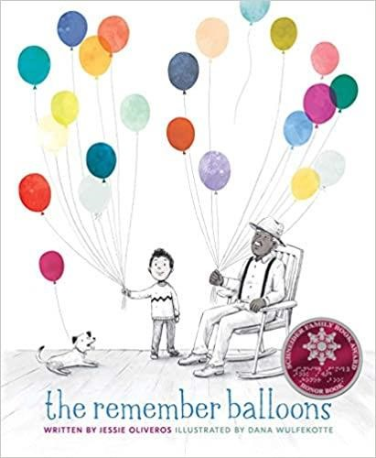 | What’s Happening to Grandpa meets Up in this tender, sensitive picture book that gently explains the memory loss associated with aging and diseases such as Alzheimer’s.  James’s Grandpa has the best balloons because he has the best memories. He has balloons showing Dad when he was young and Grandma when they were married. Grandpa has balloons about camping and Aunt Nelle’s poor cow. Grandpa also has a silver balloon filled with the memory of a fishing trip he and James took together. But when Grandpa’s balloons begin to float away, James is heartbroken. No matter how hard he runs, James can’t catch them. One day, Grandpa lets go of the silver balloon—and he doesn’t even notice! Grandpa no longer has balloons of his own. But James has many more than before. It’s up to him to share those balloons, one by one.  Available in print at the Fresno County Public Library  Muaj cov ntawv luam tawm hauv Fresno County Chaw Qiv Ntawv
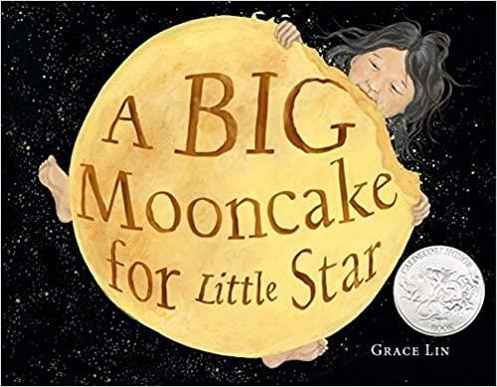 | A Caldecott Honor book  Little Star loves the delicious Mooncake that she bakes with her mama. But she's not supposed to eat any yet! What happens when she can't resist a nibble?  In this stunning picture book that shines as bright as the stars in the sky, Newbery Honor author Grace Lin creates a heartwarming original story that explains phases of the moon.  Available in print and ebook format at the Fresno County Public Library  Muaj cov ntawv luam tawm, ebook, thiab cov suab nyob ntawm Fresno County Public Library

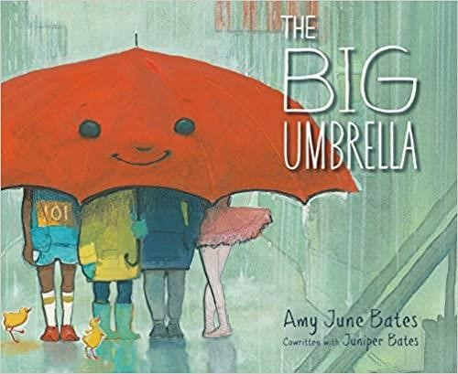 | “This sweet extended metaphor uses an umbrella to demonstrate how kindness and inclusion work...A lovely addition to any library collection, for classroom use or for sharing at home.” —School Library Journal  By the door there is an umbrella. It is big. It is so big that when it starts to rain there is room for everyone underneath. It doesn’t matter if you are tall. Or plaid. Or hairy. It doesn’t matter how many legs you have. Don’t worry that there won’t be enough room under the umbrella. Because there will always be room.  Available in print at the Fresno County Public Library  Muaj cov ntawv luam tawm hauv Fresno County Chaw Qiv Ntawv
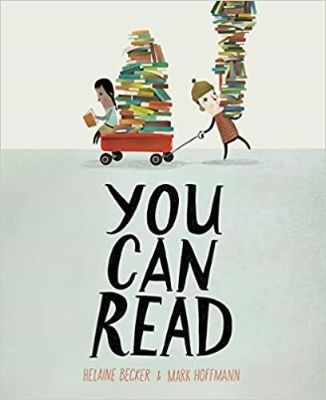 | In this fun and funny celebration of literacy, kids of all ages will discover that the act of reading is a daring adventure that can take you anywhere! You can read at the playground, under the sea, at the opera and even in outer space! It turns out you can read everywhere! And when you do, you open yourself to a universe of adventure.  Presented in light-hearted, rib-tickling verse that's perfect for reading aloud, You Can Read sings it loud and proud: Books are awesome. And so are the people who read them.  Available in print and ebook format at the Fresno County Public Library  Muaj cov ntawv luam tawm, ebook, thiab cov suab nyob ntawm Fresno County Public Library
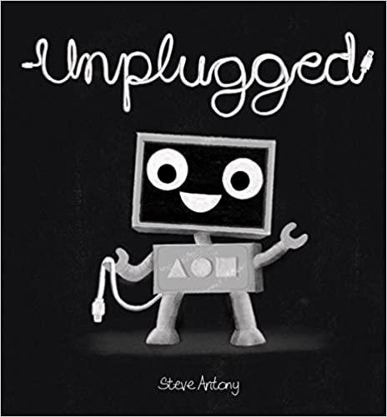 | Meet Blip. Blip loves being plugged into her computer. When a blackout occurs, Blip trips over her wire and tumbles outside.  Suddenly, Blip's gray world is filled with color and excitement. She plays with her new friends and has adventures all day long. When Blip finally returns home, she realizes that the world can be even brighter once you unplug.  Available in print at the Fresno County Public Library  Muaj cov ntawv luam tawm hauv Fresno County Chaw Qiv Ntawv

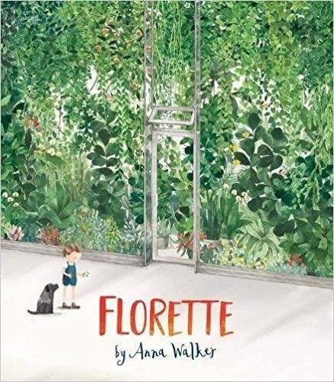 | A 2018 New York Times and New York Public Library Best Illustrated Picture Book  When Mae’s family moves to a new home, she wishes she could bring her garden with her. She’ll miss the apple trees, the daffodils, and chasing butterflies in the wavy grass. But there’s no room for a garden in the city. Or is there?  Mae’s story, gorgeously illustrated in watercolor, is a celebration of friendship, resilience in the face of change, and the magic of the natural world.  Available in print at the Fresno County Public Library  Muaj cov ntawv luam tawm hauv Fresno County Chaw Qiv Ntawv
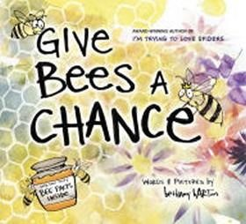 | Not sure whether to high-five bees or run away from them? Well, maybe you shouldn't high-five them, but you definitely don't have to run away from them. Give Bees a Chance is for anyone who doesn't quite appreciate how extra special and important bees are to the world, and even to humankind! Besides making yummy honey, they help plants grow fruits and vegetables. And most bees wouldn't hurt a fly (unless it was in self-defense!). Bethany Barton's interactive cartoon-style illustrations and hilarious narrator mean this book is full of facts and fun. With bees officially on the endangered animals list, it's more important now than ever to get on board with our flying, honey-making friends!  Available in print at the Fresno County Public Library  Muaj cov ntawv luam tawm hauv Fresno County Chaw Qiv Ntawv
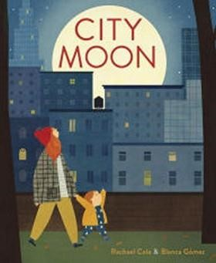 | A little boy and his mother take a nighttime walk to search for the moon in this Ezra Jack Keats New Writer Honor book.  Soothing text and hip, colorful collage style illustrations create a nighttime story that follows a little boy and his Mama as they walk around their neighborhood looking for the moon. As the elusive moon plays peek-a-boo behind buildings and clouds, the little boy asks simple questions about it, and his Mama patiently answers every one. When finally the moon appears—bright and white and round and glowing—the mama and her boy stop and wait for it to disappear again. The moonlit walk continues until the boy yawns and Mama lifts him into her arms and whispers, "it is time for bed."  Available in print at the Fresno County Public Library  Muaj cov ntawv luam tawm hauv Fresno County Chaw Qiv Ntawv

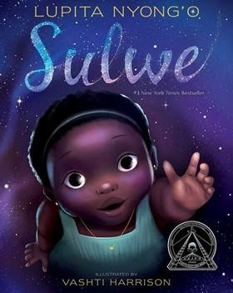 | A New York Times bestseller; Recipient of a Coretta Scott King Illustrator Honor  Award; Recipient of an NAACP Image Award for Outstanding Children’s Literary Work  From Academy Award–winning actress Lupita Nyong’o comes a powerful, moving picture book about colorism, self-esteem, and learning that true beauty comes from within.  Sulwe has skin the color of midnight. She is darker than everyone in her family. She is darker than anyone in her school. Sulwe just wants to be beautiful and bright, like her mother and sister. Then a magical journey in the night sky opens her eyes and changes everything.  Available in print and ebook format at the Fresno County Public Library  Muaj cov ntawv luam tawm, ebook, thiab cov suab nyob ntawm Fresno County Public Library
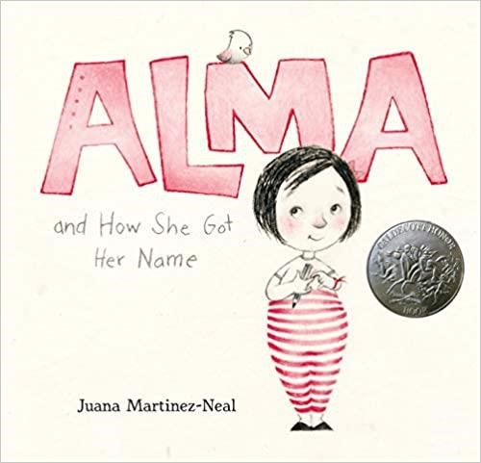 | A 2019 Caldecott Honor Book  What’s in a name? For one little girl, her very long name tells the vibrant story of where she came from — and who she may one day be.  If you ask her, Alma Sofia Esperanza José Pura Candela has way too many names: six! How did such a small person wind up with such a large name? Alma turns to Daddy for an answer and learns of Sofia, the grandmother who loved books and flowers; Esperanza, the great-grandmother who longed to travel; José, the grandfather who was an artist; and other namesakes, too. As she hears the story of her name, Alma starts to think it might be a perfect fit after all — and realizes that she will one day have her own story to tell.  Available in print, ebook and DVD at the Fresno County Public Library  Muaj cov ntawv luam tawm, ebook, thiab cov suab nyob ntawm Fresno County Public Library
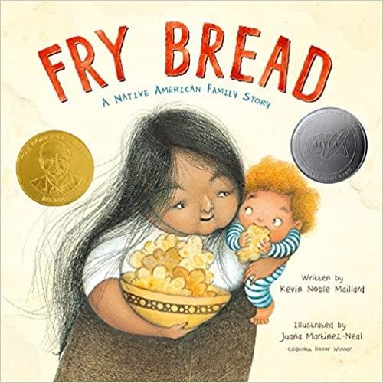 | Winner of the 2020 Robert F. Sibert Informational Book Medal; A 2020 American Indian Youth Literature Picture Book Honor Winner  Told in lively and powerful verse by debut author Kevin Noble Maillard, Fry Bread is an evocative depiction of a modern Native American family, vibrantly illustrated by Pura Belpre Award winner and Caldecott Honoree Juana Martinez-Neal.  It is a celebration of old and new, traditional and modern, similarity and difference.  Available in print at the Fresno County Public Library  Muaj cov ntawv luam tawm hauv Fresno County Chaw Qiv Ntawv

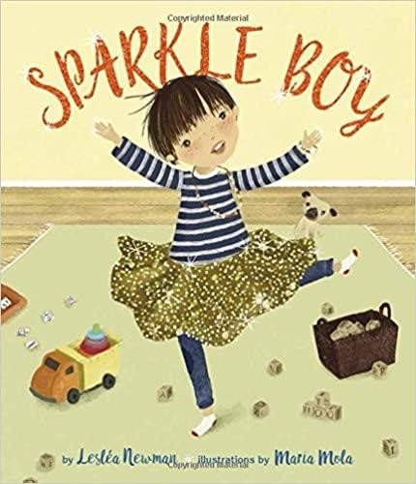 | Casey loves to play with his blocks, puzzles, and dump truck, but he also loves things that sparkle, shimmer, and glitter. When his older sister, Jessie, shows off her new shimmery skirt, Casey wants to wear a shimmery skirt too. When Jessie comes home from a party with glittery nails, Casey wants glittery nails too. And when Abuelita visits wearing an armful of sparkly bracelets, Casey gets one to wear, just like Jessie. The adults in Casey's life embrace his interests, but Jessie isn't so sure. Boys aren't supposed to wear sparkly, shimmery, glittery things. Then, when older boys at the library tease Casey for wearing "girl" things, Jessie realizes that Casey has the right to be himself and wear whatever he wants. Here is a sweet, heartwarming story about acceptance, respect, and the freedom to be yourself in a world where any gender expression should be celebrated.  Available in print at the Fresno County Public Library  Muaj cov ntawv luam tawm hauv Fresno County Chaw Qiv Ntawv
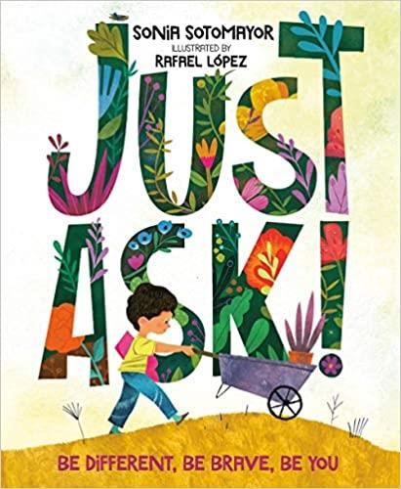 | A #1 New York Times bestseller; Winner of the Schneider Family Book Award  Supreme Court Justice Sonia Sotomayor and award-winning artist Rafael Lopez create a kind and caring book about the differences that make each of us unique.  Feeling different, especially as a kid, can be tough. But in the same way that different types of plants and flowers make a garden more beautiful and enjoyable, different types of people make our world more vibrant and wonderful.  As the kids work together to build a community garden, asking questions of each other along the way, this book encourages readers to do the same: When we come across someone who is different from us but we're not sure why, all we have to do is Just Ask.  Available in print at the Fresno County Public Library  Muaj cov ntawv luam tawm hauv Fresno County Chaw Qiv Ntawv
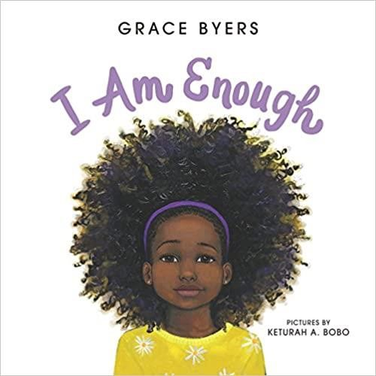 | A #1 New York Times bestseller; Goodreads Choice Awards picture book winner  This gorgeous, lyrical ode to loving who you are, respecting others, and being kind to one another comes from Empire actor and activist Grace Byers and talented newcomer artist Keturah A. Bobo. We are all here for a purpose. We are more than enough. We just need to believe it.  Available in print, ebook, and audio formats at the Fresno County Public Library  Muaj cov ntawv luam tawm, ebook, thiab cov suab nyob ntawm Fresno County Public Library

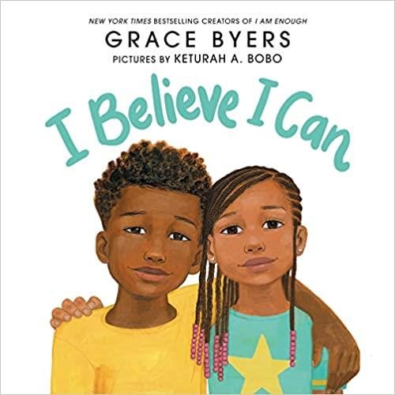 | From the #1 New York Times bestselling creators of I Am Enough comes an empowering follow-up that celebrates every child’s limitless potential.  I Believe I Can is an affirmation for boys and girls of every background to love and believe in themselves.  My presence matters in this world. I know I can do anything, if only I believe I can.  Available in print, ebook and audio formats at the Fresno County Public Library  Muaj cov ntawv luam tawm, ebook, thiab cov suab nyob ntawm Fresno County Public Library
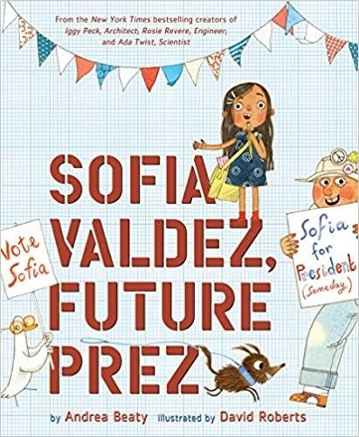 | #1 New York Times, USA Today, and Wall Street Journal bestseller  Every morning, Abuelo walks Sofia to school...until one day, when Abuelo hurts his ankle at a local landfill and he can no longer do so. Sofia (aka Sofi) misses her Abuelo and wonders what she can do about the dangerous Mount Trashmore.  Then she gets an idea—the town can turn the slimy mess into a park! She brainstorms and plans and finally works up the courage to go to City Hall— only to be told by a clerk that she can’t build a park because she’s just a kid! Sofia is down but not out, and she sets out to prove what one kid can do.  Available in print and ebook format at the Fresno County Public Library  Muaj cov ntawv luam tawm, ebook, thiab cov suab nyob ntawm Fresno County Public Library
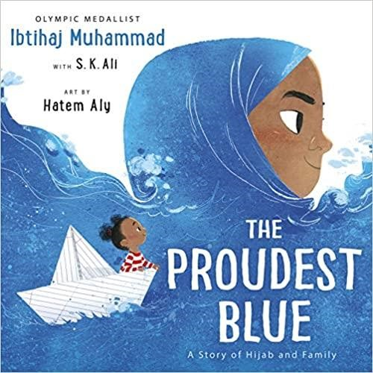 | New York Times bestseller  A powerful, vibrantly illustrated story about the first day of school—and two sisters on one's first day of hijab—by Olympic medalist and social justice activist Ibtihaj Muhammad.  With her new backpack and light-up shoes, Faizah knows the first day of school is going to be special. It's the start of a brand new year and, best of all, it's her older sister Asiya's first day of hijab—a hijab of beautiful blue fabric, like the ocean waving to the sky. But not everyone sees hijab as beautiful, and in the face of hurtful, confusing words, Faizah will find new ways to be strong.  Available in print and ebook format at the Fresno County Public Library  Muaj cov ntawv luam tawm, ebook, thiab cov suab nyob ntawm Fresno County Public Library

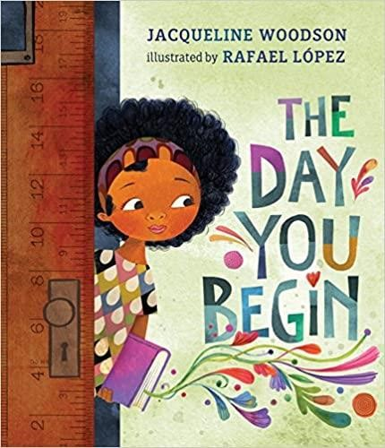 | #1 New York Times bestseller  National Book Award winner Jacqueline Woodson and two-time Pura Belpré Illustrator Award winner Rafael López have teamed up to create a poignant, yet heartening book about finding courage to connect, even when you feel scared and alone.  There will be times when you walk into a room and no one there is quite like you. There are many reasons to feel different. Maybe it's how you look or talk, or where you're from; maybe it's what you eat, or something just as random. It's not easy to take those first steps into a place where nobody really knows you yet, but somehow you do it.  Available in print, ebook, and audio format at the Fresno County Public Library  Muaj cov ntawv luam tawm, ebook, thiab cov suab nyob ntawm Fresno County Public Library
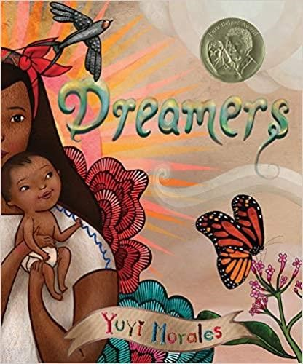 | This lovingly-illustrated picture book memoir looks at the myriad gifts migrantes bring with them when they leave their homes. It's a story about family. And it's a story to remind us that we are all dreamers, bringing our own strengths wherever we roam. Beautiful and powerful at any time but given particular urgency as the status of our own Dreamers becomes uncertain, this is a story that is both topical and timeless.  The lyrical text is complemented by sumptuously detailed illustrations, rich in symbolism. Also included are a brief autobiographical essay about Yuyi's own experience, a list of books that inspired her, and a description of the beautiful images, textures, and mementos she used to create this book. A parallel Spanish-language edition, Soñadores, is also available.  Available in print, ebook, and DVD formats at the Fresno County Public Library  Muaj cov ntawv luam tawm, ebook, thiab cov suab nyob ntawm Fresno County Public Library
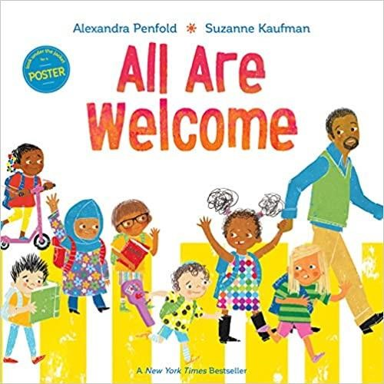 | Join the call for a better world with this New York Times bestselling picture book about a school where diversity and inclusion are celebrated.  Discover a school where—no matter what—young children have a place, have a space, and are loved and appreciated.  Follow a group of children through a day in their school, where everyone is welcomed with open arms. A school where students from all backgrounds learn from and celebrate each other's traditions. A school that shows the world as we will make it to be.  Available in print and ebook format at the Fresno County Public Library  Muaj cov ntawv luam tawm, ebook, thiab cov suab nyob ntawm Fresno County Public Library

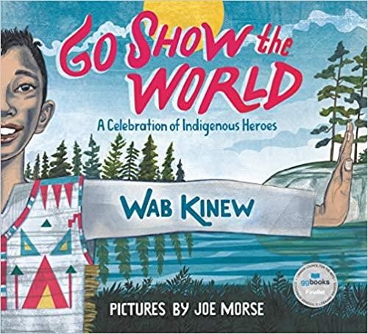 | Celebrating the stories of Indigenous people throughout time, Wab Kinew has created a powerful rap song, the lyrics of which are the basis for the text in this beautiful picture book, illustrated by the acclaimed Joe Morse. Including figures such as Crazy Horse, Net-no-kwa, former NASA astronaut John Herrington and Canadian NHL goalie Carey Price, Go Show the World showcases a diverse group of Indigenous people in the US and Canada, both the more well known and the not- so-widely recognized. Individually, their stories, though briefly touched on, are inspiring; collectively, they empower the reader with this message: "We are people who matter, yes, it's true; now let's show the world what people who matter can do."  Available in print at the Fresno County Public Library  Muaj cov ntawv luam tawm hauv Fresno County Chaw Qiv Ntawv
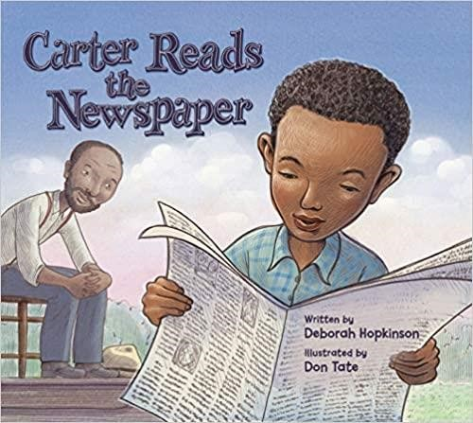 | Carter G. Woodson was born to two formerly enslaved people ten years after the end of the Civil War. Though his father could not read, he believed in being an informed citizen. So Carter read the newspaper to him every day. When he was still a teenager, Carter went to work in the coal mines. There he met a man named Oliver Jones, and Oliver did something important: he asked Carter not only to read to him and the other miners, but also research and find more information on the subjects that interested them. “My interest in penetrating the past of my people was deepened,” Carter wrote. His journey would take him many more years, traveling around the world and transforming the way people thought about history.  From an award-winning team of author Deborah Hopkinson and illustrator Don Tate, this first-ever picture book biography of Carter G. Woodson emphasizes the importance of pursuing curiosity and encouraging a hunger for knowledge of stories and histories that have not been told. Illustrations also feature brief biological sketches of important figures from African and African-American history.  Available in print at the Fresno County Public Library  Muaj cov ntawv luam tawm hauv Fresno County Chaw Qiv Ntawv
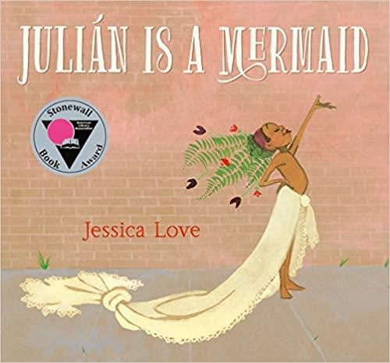 | While riding the subway home from the pool with his abuela one day, Julián notices three women spectacularly dressed up. Their hair billows in brilliant hues, their dresses end in fishtails, and their joy fills the train car. When Julián gets home, daydreaming of the magic he’s seen, all he can think about is dressing up just like the ladies in his own fabulous mermaid costume: a butteryellow curtain for his tail, the fronds of a potted fern for his headdress. But what will Abuela think about the mess he makes — and even more importantly, what will she think about how Julián sees himself? Mesmerizing and full of heart, Jessica Love’s author-illustrator debut is a jubilant picture of self-love and a radiant celebration of individuality.  Available in print at the Fresno County Public Library  Muaj cov ntawv luam tawm hauv Fresno County Chaw Qiv Ntawv

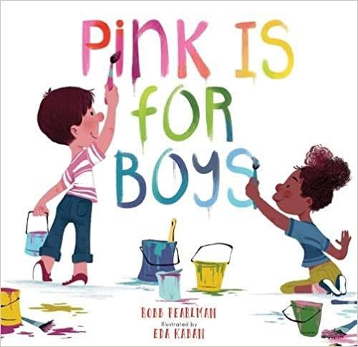 | Pink is for boys...and girls...and everyone! This timely and beautiful picture book rethinks and reframes the stereotypical blue/pink gender binary and empowers kids-and their grown-ups-to express themselves in every color of the rainbow. Featuring a diverse group of relatable characters, Pink Is for Boys invites and encourages girls and boys to enjoy what they love to do, whether it's racing cars and playing baseball, or loving unicorns and dressing up.  Available in print at the Fresno County Public Library  Muaj cov ntawv luam tawm hauv Fresno County Chaw Qiv Ntawv
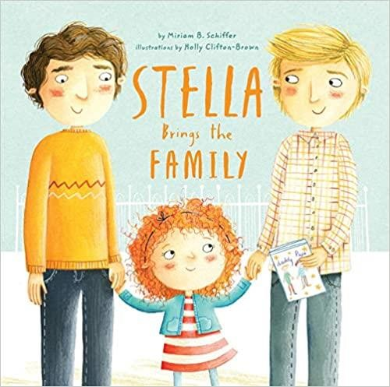 | Stella's class is having a Mother's Day celebration, but what's a girl with two daddies to do? It's not that she doesn't have someone who helps her with her homework, or tucks her in at night. Stella has her Papa and Daddy who take care of her, and a whole gaggle of other loved ones who make her feel special and supported every day. She just doesn't have a mom to invite to the party. Fortunately, Stella finds a unique solution to her party problem in this sweet story about love, acceptance, and the true meaning of family.  Available in print and ebook format at the Fresno County Public Library  Muaj cov ntawv luam tawm, ebook, thiab cov suab nyob ntawm Fresno County Public Library
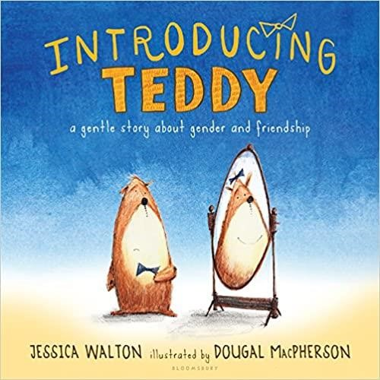 | Introducing Teddy introduces the youngest readers to understanding gender identity and transition in an accessible and heart-warming story about being true to yourself and being a good friend.  Errol and his teddy, Thomas, are best friends who do everything together. Whether it's riding a bike, playing in the tree house, having a tea party, or all of the above, every day holds something fun to do.  One sunny day, Errol finds that Thomas is sad, even when they are playing in their favorite ways. Errol can't figure out why, until Thomas finally tells Errol what the teddy has been afraid to say: "In my heart, I've always known that I'm a girl teddy, not a boy teddy. I wish my name was Tilly, not Thomas." And Errol says, "I don't care if you're a girl teddy or a boy teddy! What matters is that you are my friend."  Available in print at the Fresno County Public Library  Muaj cov ntawv luam tawm hauv Fresno County Chaw Qiv Ntawv

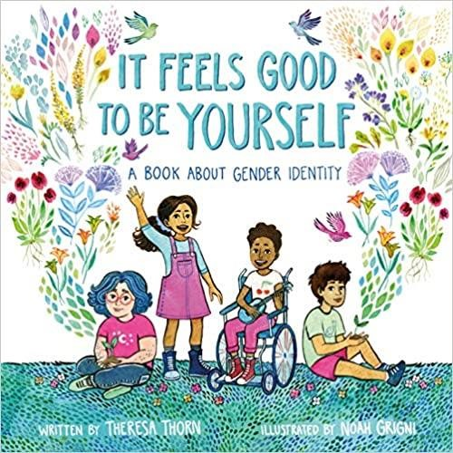 | Some people are boys. Some people are girls. Some people are both, neither, or somewhere in between.  This sweet, straightforward exploration of gender identity will give children a fuller understanding of themselves and others. With child-friendly language and vibrant art, It Feels Good to Be Yourself provides young readers and parents alike with the vocabulary to discuss this important topic with sensitivity.  Available in print at the Fresno County Public Library  Muaj cov ntawv luam tawm hauv Fresno County Chaw Qiv Ntawv
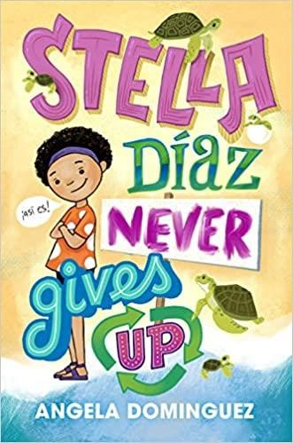 | From award-winning author Angela Dominguez comes the novel Stella Diaz Never Gives Up, a story about a shy Mexican-American girl who becomes an environmental activist and makes a difference in her community.  Stella gets a big surprise when her mom plans a trip to visit their family in Mexico! Stella loves marine animals, and she can't wait to see the ocean for the first time . . . until she arrives and learns that the sea and its life forms are in danger due to pollution.  Stella wants to save the ocean, but she knows she can't do it alone. It's going to take a lot of work and help from old and new friends to make a difference, but Stella Díaz never gives up!  Available in print and ebook format at the Fresno County Public Library  Muaj cov ntawv luam tawm, ebook, thiab cov suab nyob ntawm Fresno County Public Library
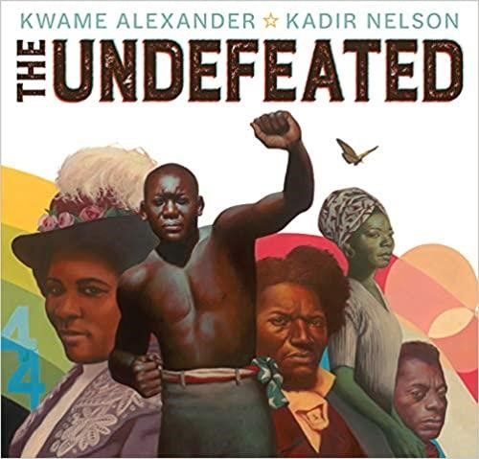 | Winner of the 2020 Caldecott Medal; A 2020 Newbery Honor Book; Winner of the 2020 Coretta Scott King Illustrator Award  The Newbery Award-winning author of The Crossover pens an ode to black American triumph and tribulation, with art from a two-time Caldecott Honoree. Originally performed for ESPN's The Undefeated, this poem is a love letter to black life in the United States. It highlights the unspeakable trauma of slavery, the faith and fire of the civil rights movement, and the grit, passion, and perseverance of some of the world's greatest heroes.  Available in print and ebook format at the Fresno County Public Library  Muaj cov ntawv luam tawm, ebook, thiab cov suab nyob ntawm Fresno County Public Library

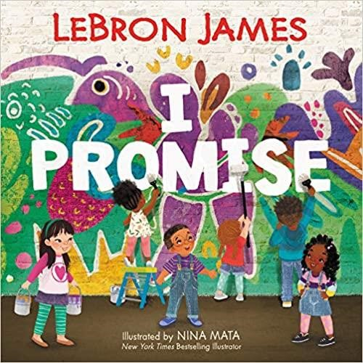 | #1 New York Times Bestseller  NBA champion and superstar LeBron James pens a slam-dunk picture book inspired by his foundation’s I PROMISE program that motivates children everywhere to always #StriveForGreatness. Just a kid from Akron, Ohio, who is dedicated to uplifting youth everywhere, LeBron James knows the key to a better future is to excel in school, do your best, and keep your family close. I Promise is a lively and inspiring picture book that reminds us that tomorrow’s success starts with the promises we make to ourselves and our community today.  Available in print, ebook, and audio format at the Fresno County Public Library  Muaj cov ntawv luam tawm, ebook, thiab cov suab nyob ntawm Fresno County Public Library
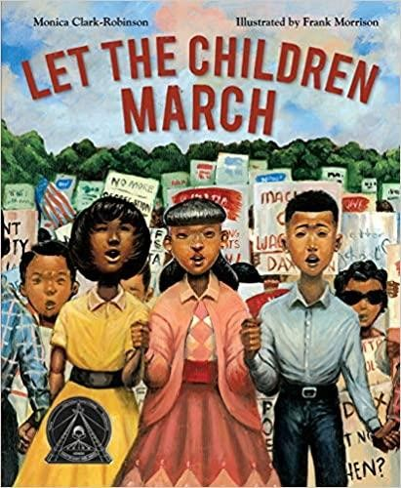 | Coretta Scott King Honor Award for Illustration  I couldn't play on the same playground as the white kids. I couldn't go to their schools. I couldn't drink from their water fountains. There were so many things I couldn't do.  In 1963 Birmingham, Alabama, thousands of African American children volunteered to march for their civil rights after hearing Dr. Martin Luther King Jr. speak. They protested the laws that kept black people separate from white people. Facing fear, hate, and danger, these children used their voices to change the world. Frank Morrison's emotive oil-on-canvas paintings bring this historical event to life, while Monica Clark-Robinson's moving and poetic words document this remarkable time.  Available in print and DVD format at the Fresno County Public Library  Muaj cov ntawv luam tawm thiab DVD rau ntawm Fresno Hauv Paus Tsev Kawm Ntawv Chaw Qiv Ntawv
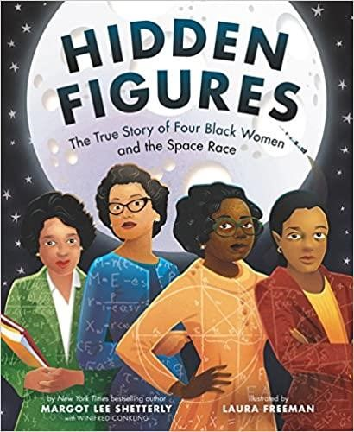 | Based on the New York Times bestselling book and the Academy Award– nominated movie, author Margot Lee Shetterly and Coretta Scott King Illustrator Honor Award winner Laura Freeman bring the incredibly inspiring true story of four black women who helped NASA launch men into space to picture book readers!  Dorothy Vaughan, Mary Jackson, Katherine Johnson, and Christine Darden were good at math…really good.  They participated in some of NASA's greatest successes, like providing the calculations for America's first journeys into space. And they did so during a time when being black and a woman limited what they could do. But they worked hard. They persisted. And they used their genius minds to change the world.  Available in print at the Fresno County Public Library  Muaj cov ntawv luam tawm hauv Fresno County Chaw Qiv Ntawv

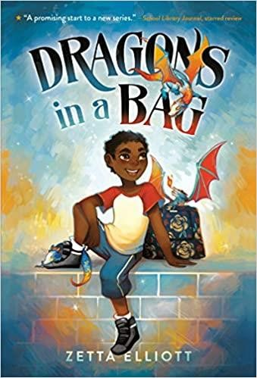 | The dragon's out of the bag in this diverse, young urban fantasy from an award-winning author.  When Jaxon is sent to spend the day with a mean old lady his mother calls Ma, he finds out she's not his grandmother--but she is a witch! She needs his help delivering baby dragons to a magical world where they'll be safe. There are two rules when it comes to the dragons: don't let them out of the bag and don't feed them anything sweet. Before he knows it, Jax and his friends Vikram and Kavita have broken both rules! Will Jax get the baby dragons delivered safe and sound? Or will they be lost in Brooklyn forever?  Available in print at the Fresno County Public Library  Muaj cov ntawv luam tawm hauv Fresno County Chaw Qiv Ntawv
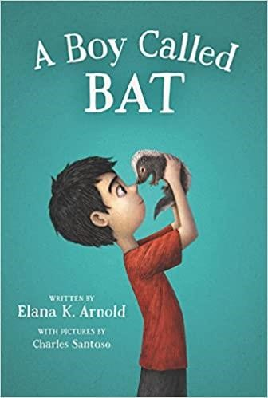 | The first book in a funny, heartfelt, and irresistible young middle grade series starring an unforgettable young boy on the autism spectrum.  For Bixby Alexander Tam (nicknamed Bat), life tends to be full of surprises— some of them good, some not so good. Today, though, is a good-surprise day. Bat’s mom, a veterinarian, has brought home a baby skunk, which she needs to take care of until she can hand him over to a wild-animal shelter.  But the minute Bat meets the kit, he knows they belong together. And he’s got one month to show his mom that a baby skunk might just make a pretty terrific pet.  Available in print, ebook, and audio format at the Fresno County Public Library  Muaj cov ntawv luam tawm, ebook, thiab cov suab nyob ntawm Fresno County Public Library
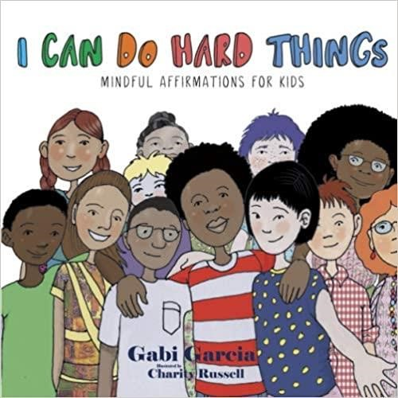 | What we tell ourselves matters! This is just as true for kids as it is for adults.  Help your child tap into their inner strength and find the encouragement they need to navigate their daily environments.  Mindful affirmations can help your child tune out the streams of messages they get about how they should be in the world.  I can choose kindness.  I can practice peace.  I can share my gifts with the world.

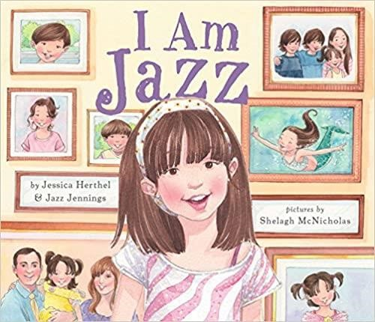 | The story of a transgender child based on the real-life experience of Jazz Jennings, who has become a spokesperson for transkids everywhere.  From the time she was two years old, Jazz knew that she had a girl's brain in a boy's body. She loved pink and dressing up as a mermaid and didn't feel like herself in boys' clothing. This confused her family, until they took her to a doctor who said that Jazz was transgender and that she was born that way. Jazz's story is based on her real-life experience and she tells it in a simple, clear way that will be appreciated by picture book readers, their parents, and teachers.  Available in print and ebook format at the Fresno County Public Library  Muaj cov ntawv luam tawm, ebook, thiab cov suab nyob ntawm Fresno County Public Library
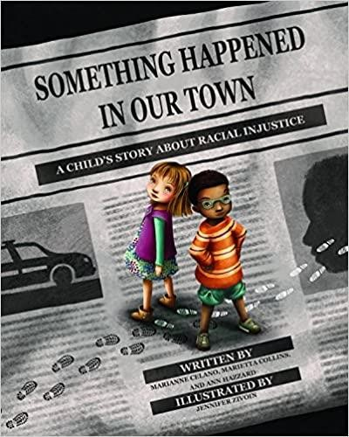 | Something Happened in Our Town: A Child’s Story About Racial Injustice follows two families — one White, one Black — as they discuss a police shooting of a Black man in their community. The story aims to answer children's questions about such traumatic events, and to help children identify and counter racial injustice in their own lives.  Includes an extensive Note to Parents and Caregivers with guidelines for discussing race and racism with children, child-friendly definitions, and sample dialogues.  Available in print and audio format at the Fresno County Public Library  Muaj cov ntawv luam tawm thiab suab ua qauv nyob rau ntawm Fresno County Public Library
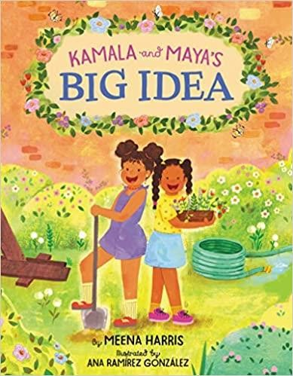 | New York Times bestseller  A beautiful, empowering picture book about two sisters who work with their community to effect change, inspired by a true story from the childhood of Meena Harris's aunt, US Senator Kamala Harris, and Meena's mother, lawyer and policy expert Maya Harris. Share this inspiring picture book with young readers to help introduce vice presidential candidate Kamala Harris.  One day, Kamala and Maya had an idea. A big idea: They would turn their empty apartment courtyard into a playground! This is the uplifting tale of how the author’s aunt and mother first learned to persevere in the face of disappointment and turned a dream into reality. This is a story of children’s ability to make a difference and of a community coming together to transform their neighborhood.  Available in print, ebook, and audio format from the Fresno County Public Library  Muaj cov ntawv luam tawm, ebook, thiab cov suab nyob ntawm Fresno County Public Library

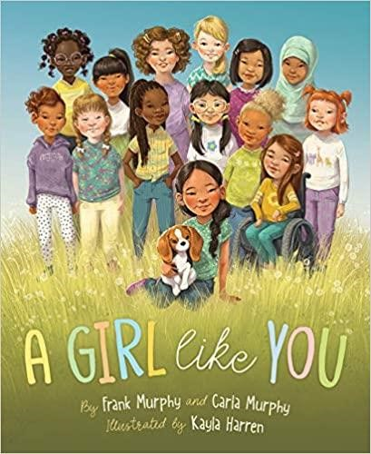 | Every girl is a wonder! A Girl Like You encourages girls to embrace what makes them unique, to choose kindness, and to be their own advocates. In an age when girls can be whatever they want, this book reminds them of all the ways to be beautiful, brilliant, and uniquely themselves.  Available in print from the Fresno County Public Library  Muaj cov ntawv luam tawm hauv Fresno County Chaw Qiv Ntawv
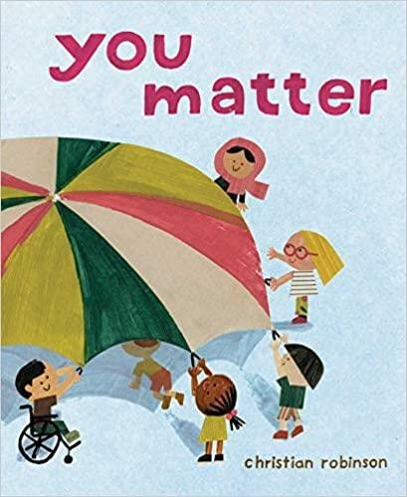 | A New York Times bestseller  In this full, bright, and beautiful picture book, many different perspectives around the world are deftly and empathetically explored—from a pair of birdwatchers to the pigeons they’re feeding. Young readers will be drawn into the luminous illustrations inviting them to engage with the world in a new way and see how everyone is connected, and that everyone matters.  Available in print from the Fresno County Public Library  Muaj cov ntawv luam tawm hauv Fresno County Chaw Qiv Ntawv

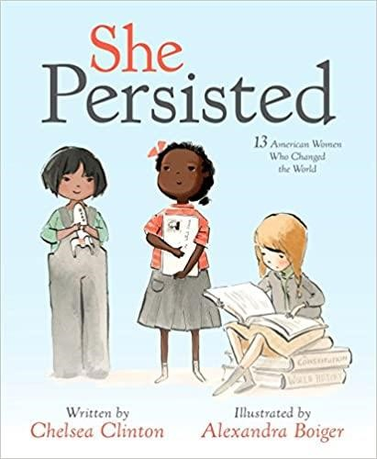 | Throughout American history, there have always been women who have spoken out for what's right, even when they have to fight to be heard. In early 2017, Senator Elizabeth Warren's refusal to be silenced in the Senate inspired a spontaneous celebration of women who persevered in the face of adversity. In this book, Chelsea Clinton celebrates thirteen American women who helped shape our country through their tenacity, sometimes through speaking out, sometimes by staying seated, sometimes by captivating an audience. They all certainly persisted.  She Persisted is for everyone who has ever wanted to speak up but has been told to quiet down, for everyone who has ever tried to reach for the stars but was told to sit down, and for everyone who has ever been made to feel unworthy or unimportant or small. This book features: Harriet Tubman, Helen Keller, Clara Lemlich, Nellie Bly, Virginia Apgar, Maria Tallchief, Claudette Colvin, Ruby Bridges, Margaret Chase Smith, Sally Ride, Florence Griffith Joyner, Oprah Winfrey, Sonia Sotomayor—and one special cameo.  Available in print, ebook, and audio format from the Fresno County Public  Library  Muaj cov ntawv luam tawm, ebook, thiab cov suab nyob ntawm Fresno County Public Library
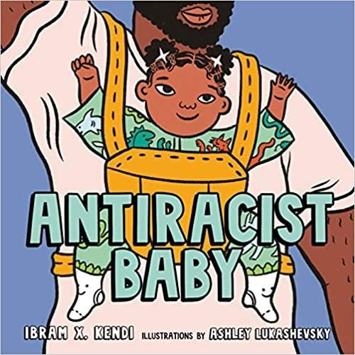 | #1 New York Times Bestseller  From the National Book Award-winning author of Stamped from the Beginning and How to Be an Antiracist comes a new picture book that empowers parents and children to uproot racism in our society and in ourselves, now with added discussion prompts to help readers recognize and reflect on bias in their daily lives. With bold art and thoughtful yet playful text, Antiracist Baby introduces the youngest readers and the grown-ups in their lives to the concept and power of antiracism.  Available in print, ebook, and audio format from the Fresno County Public  Library  Muaj cov ntawv luam tawm, ebook, thiab cov suab nyob ntawm Fresno County Public Library
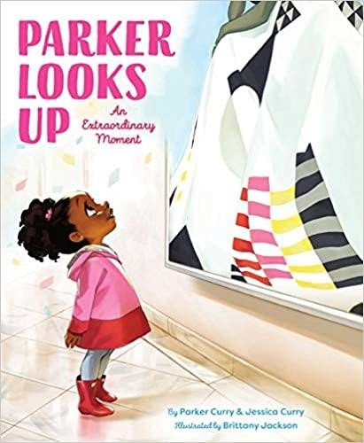 | A New York Times bestseller  Parker Looks Up follows Parker, along with her baby sister and her mother, and her best friend Gia and Gia’s mother, as they walk the halls of a museum, seeing paintings of everyone and everything from George Washington Carver to Frida Kahlo, exotic flowers to graceful ballerinas. Then, Parker walks by Sherald’s portrait of Michelle Obama…and almost passes it. But she stops...and looks up!  Parker saw the possibility and promise, the hopes and dreams of herself in this powerful painting of Michelle Obama. An everyday moment became an extraordinary one…that continues to resonate its power, inspiration, and indelible impact.  Available in print from the Fresno County Public Library  Muaj cov ntawv luam tawm hauv Fresno County Chaw Qiv Ntawv
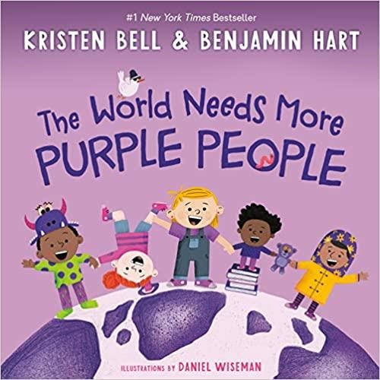 | #1 New York Times bestseller  What is a purple person? Great question. I mean, really great! Because purple people always ask really great questions. They bring their family, friends, and communities together, and they speak up for what’s right. They are kind and hardworking, and they love to laugh (especially at Grandpa’s funny noises)! A purple person is an everyday superhero! How do you become one? That’s the fun part! Penny Purple will lead you through the steps. Get ready to be silly, exercise your curiosity, use your voice, and be inspired.  Available in print, ebook, and audio format from the Fresno County Public  Library  Muaj cov ntawv luam tawm, ebook, thiab cov suab nyob ntawm Fresno County Public Library
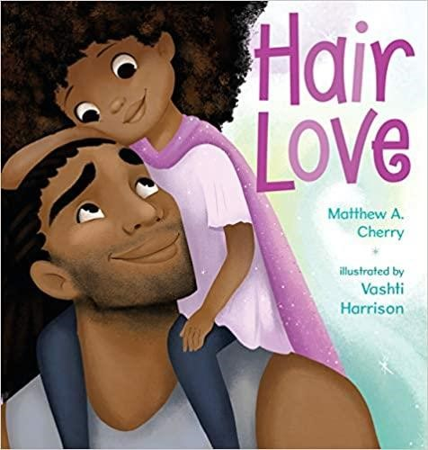 | Zuri's hair has a mind of its own. It kinks, coils, and curls every which way. Zuri knows it's beautiful. When Daddy steps in to style it for an extra special occasion, he has a lot to learn. But he LOVES his Zuri, and he'll do anything to make her -- and her hair -- happy.  Tender and empowering, Hair Love is an ode to loving your natural hair -- and a celebration of daddies and daughters everywhere.  Available in print, ebook, and audio format from the Fresno County Public  Library  Muaj cov ntawv luam tawm, ebook, thiab cov suab nyob ntawm Fresno County Public Library
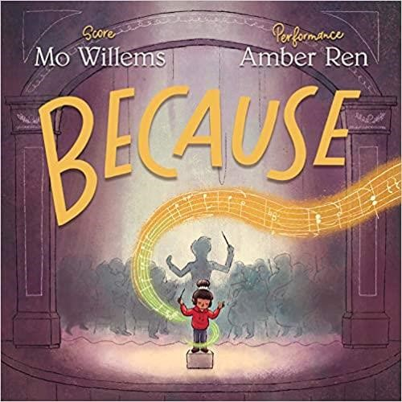 | Mo Willems, a number one New York Times best-selling author and illustrator, composes a powerful symphony of chance, discovery, persistence, and magic in this moving tale of a young girl's journey to center stage. Illustrator Amber Ren brings Willems' music to life, conducting a stunning picture-book debut.  Available in print format at the Fresno County Public Library  Muaj cov ntawv luam tawm hauv Fresno County Chaw Qiv Ntawv

