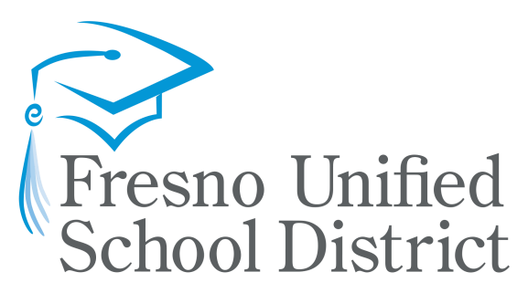

Pom Zoo Nyeem Cov Phau Ntawv

Qib 3-5

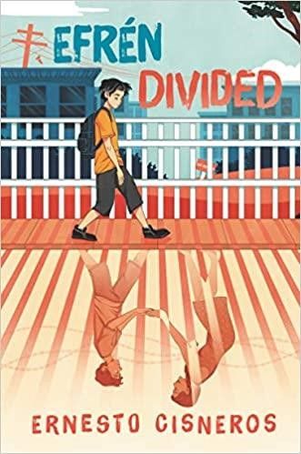 | Efrén Nava’s Amá is his Superwoman—or Soperwoman, named after the delicious Mexican sopes his mother often prepares. Both Amá and Apá work hard all day to provide for the family, making sure Efrén and his younger siblings Max and Mía feel safe and loved.  But Efrén worries about his parents; although he’s American-born, his parents are undocumented. His worst nightmare comes true one day when Amá doesn’t return from work and is deported across the border to Tijuana, México.  Now more than ever, Efrén must channel his inner Soperboy to help take care of and try to reunite his family.  A glossary of Spanish words is included in the back of the book.  Available in print and ebook format at the Fresno County Public Library  Muaj cov ntawv luam tawm thiab ebook tawm ntawm Fresno County Lub Tsev Qiv Ntawv
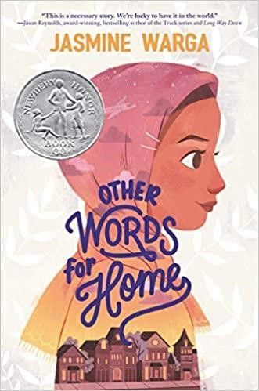 | New York Times bestseller and Newbery Honor Book.  A gorgeously written, hopeful middle grade novel in verse about a young girl who must leave Syria to move to the United States, perfect for fans of Jason Reynolds and Aisha Saeed.  Jude never thought she’d be leaving her beloved older brother and father behind, all the way across the ocean in Syria. But when things in her hometown start becoming volatile, Jude and her mother are sent to live in Cincinnati with relatives. At first, everything in America seems too fast and too loud. The American movies that Jude has always loved haven’t quite prepared her for starting school in the US—and her new label of “Middle Eastern,” an identity she’s never known before. But this life also brings unexpected surprises—there are new friends, a whole new family, and a school musical that Jude might just try out for. Maybe America, too, is a place where Jude can be seen as she really is.  Available in print, ebook, and audio format at the Fresno County Public Library  Muaj cov ntawv luam tawm thiab ebook tawm ntawm Fresno County Lub Tsev Qiv Ntawv

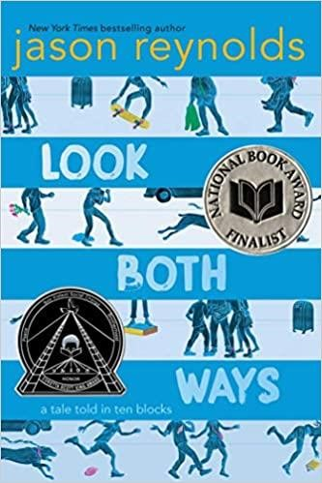 | A National Book Award Finalist; Coretta Scott King Author Honor Book; An NPR Favorite Book of  2019; A New York Times Best Children’s Book of 2019; A School Library Journal Best Middle Grade Book of 2019  From National Book Award finalist and #1 New York Times bestselling author Jason Reynolds comes a novel told in ten blocks, showing all the different directions kids’ walks home can take.  Jason Reynolds conjures ten tales (one per block) about what happens after the dismissal bell rings, and brilliantly weaves them into one wickedly funny, piercingly poignant look at the detours we face on the walk home, and in life.  Available in print, ebook, and audio format at the Fresno County Public Library  Muaj cov ntawv luam tawm thiab ebook tawm ntawm Fresno County Lub Tsev Qiv Ntawv
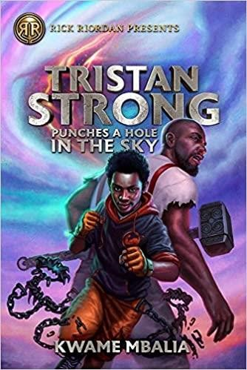 | Best-selling author Rick Riordan presents Kwame Mbalia's epic fantasy, a middle grade American Gods set in a richly-imagined world populated with African American folk heroes and West African gods.  Seventh grader Tristan Strong feels anything but strong ever since he failed to save his best friend when they were in a bus accident together. All he has left of Eddie is the journal his friend wrote stories in. Tristan is dreading the month he's going to spend on his grandparents' farm in Alabama, where he's being sent to heal from the tragedy. But on his first night there, a sticky creature shows up in his bedroom and steals Eddie's notebook. Tristan chases after it--is that a doll?--and a tug-of-war ensues between them underneath a Bottle Tree. In a last attempt to wrestle the journal out of the creature's hands, Tristan punches the tree, accidentally ripping open a chasm into the MidPass, a volatile place with a burning sea, haunted bone ships, and iron monsters that are hunting the inhabitants of this world. Tristan finds himself in the middle of a battle that has left black American folk heroes John Henry and Brer Rabbit exhausted. In order to get back home, Tristan and these new allies will need to entice the god Anansi, the Weaver, to come out of hiding and seal the hole in the sky. But bartering with the trickster Anansi always comes at a price.  First in a series.  Available in print, ebook, and audio format at the Fresno County Public Library  Muaj cov ntawv luam tawm thiab ebook tawm ntawm Fresno County Lub Tsev Qiv Ntawv
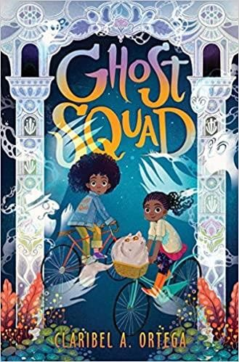 | For Lucely Luna, ghosts are more than just the family business. Shortly before Halloween, Lucely and her best friend, Syd, cast a spell that accidentally awakens malicious spirits, wreaking havoc throughout St. Augustine. Together, they must join forces with Syd's witch grandmother, Babette, and her tubby tabby, Chunk, to fight the haunting head-on and reverse the curse to save the town and Lucely's firefly spirits before it's too late. With the family dynamics of Coco and action-packed adventure of Ghostbusters, Claribel A. Ortega delivers both a thrillingly spooky and delightfully sweet debut novel.  Available in print, ebook, and audio format at the Fresno County Public Library  Muaj cov ntawv luam tawm thiab ebook tawm ntawm Fresno County Lub Tsev Qiv Ntawv  Grade 3-7

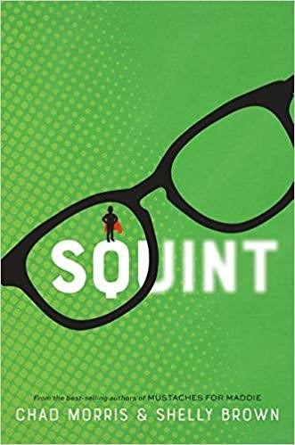 | Flint loves to draw. In fact, he's furiously trying to finish his comic book so he can be the youngest winner of the Find a Comic Star contest. He’s also rushing to finish because he has keratoconus, an eye disease that could eventually make him blind.  McKell is the new girl at school and immediately hangs with the popular kids. Except McKell's not a fan of the way her friends treat this boy named Squint. He seems nice and really talented. He draws awesome pictures of superheroes. McKell wants to get to know him, but is it worth the risk?  Squint is the inspiring story of two new friends dealing with their own challenges, who learn to trust each other, believe in themselves, and begin to truly see what matters most.
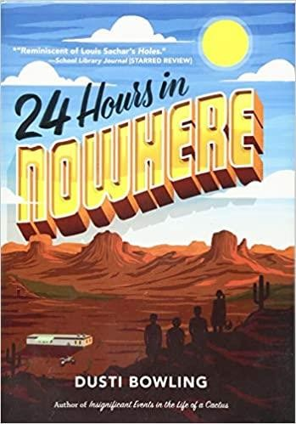 | When you come from Nowhere, can you ever really make it anywhere? Author Dusti Bowling  (Insignificant Events in the Life of a Cactus) returns to the desert to create a gripping story about friendship, hope, and finding the power we all have within ourselves.  Welcome to Nowhere, Arizona, the least livable town in the United States. For Gus, a bright 13year-old with dreams of getting out and going to college, life there is made even worse by Bo Taylor, Nowhere’s biggest, baddest bully. When Bo tries to force Gus to eat a dangerously spiny cactus, Rossi Scott, one of the best racers in Nowhere, comes to his rescue—but in return she has to give Bo her prized dirt bike. Determined to buy it back, Gus agrees to go searching for gold in Dead Frenchman Mine, joined by his old friends Jessie Navarro and Matthew Dufort, and Rossi herself. As they hunt for treasure, narrowly surviving everything from cave-ins to mountain lions, they bond over shared stories of how hard life in Nowhere is—and they realize this adventure just may be their way out.  Available in print, ebook, and audio format at the Fresno County Public Library  Muaj cov ntawv luam tawm thiab ebook tawm ntawm Fresno County Lub Tsev Qiv Ntawv
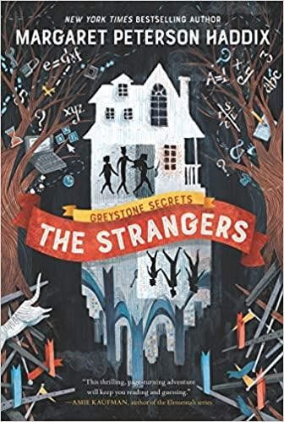 | Winter 2018–2019 Kids' Indie Next List Pick; Indie Bestseller; Time for Kids Book Club: Top 10 Summer Reads  What makes you you? The Greystone kids thought they knew. Chess has always been the protector over his younger siblings, Emma loves math, and Finn does what Finn does best— acting silly and being adored. But everything changes when reports of three kidnapped children reach the Greystone kids, and they’re shocked by the startling similarities between themselves and these complete strangers. The other kids share their same first and middle names. They’re the same ages. They even have identical birthdays. Who, exactly, are these strangers? Before Chess, Emma, and Finn can question their mom about it, she takes off on a sudden work trip and leaves them in the care of Ms. Morales and her daughter, Natalie. But puzzling clues left behind lead to complex codes, hidden rooms, and a dangerous secret that will turn their world upside down.  First book in a series.  Available in print, ebook, and audio format at the Fresno County Public Library  Muaj cov ntawv luam tawm thiab ebook tawm ntawm Fresno County Lub Tsev Qiv Ntawv

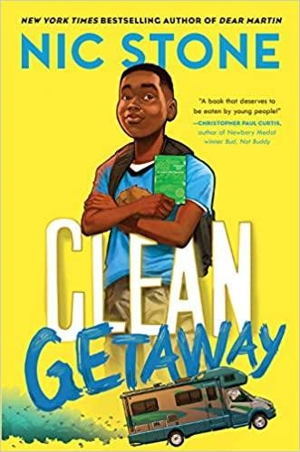 | From #1 New York Times bestselling author Nic Stone comes a middle-grade road-trip story through American race relations past and present.  Set against the backdrop of the segregation history of the American South, take a trip with this New York Times bestseller and an eleven-year-old boy who is about to discover that the world hasn't always been a welcoming place for kids like him, and things aren't always what they seem-his G'ma included."  Available in print, ebook, and audio format at the Fresno County Public Library  Muaj cov ntawv luam tawm thiab ebook tawm ntawm Fresno County Lub Tsev Qiv Ntawv
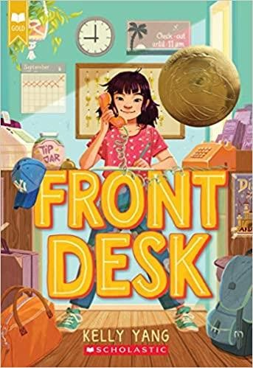 | Winner of the Asian / Pacific American Award for Children's Literature  Mia Tang has a lot of secrets.  Number 1: She lives in a motel, not a big house. Every day, while her immigrant parents clean the rooms, ten-year-old Mia manages the front desk of the Calivista Motel and tends to its guests. Number 2: Her parents hide immigrants. And if the mean motel owner, Mr. Yao, finds out they've been letting them stay in the empty rooms for free, the Tangs will be doomed.  Number 3: She wants to be a writer. But how can she when her mom thinks she should stick to math because English is not her first language? It will take all of Mia's courage, kindness, and hard work to get through this year. Will she be able to hold on to her job, help the immigrants and guests, escape Mr. Yao, and go for her dreams?  Available in print, ebook, and audio format at the Fresno County Public Library  Muaj cov ntawv luam tawm thiab ebook tawm ntawm Fresno County Lub Tsev Qiv Ntawv
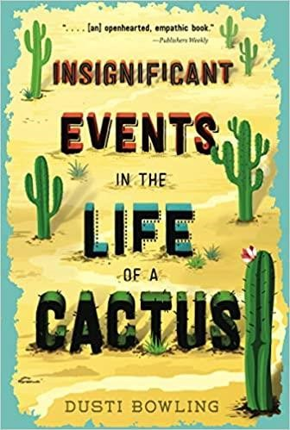 | Bestselling middle grade novel about a spunky girl born without arms and a boy with Tourette syndrome navigating the challenges of middle school, disability, and friendship—all while solving a mystery in a western theme park.  Aven Green loves to tell people that she lost her arms in an alligator wrestling match, or a wildfire in Tanzania, but the truth is she was born without them. And when her parents take a job running Stagecoach Pass, a rundown western theme park in Arizona, Aven moves with them across the country knowing that she’ll have to answer the question over and over again. Her new life takes an unexpected turn when she bonds with Connor, a classmate who also feels isolated because of his own disability, and they discover a room at Stagecoach Pass that holds bigger secrets than Aven ever could have imagined. It’s hard to solve a mystery, help a friend, and face your worst fears. But Aven’s about to discover she can do it all . . . even without arms.  Available in print, ebook, and audio format at the Fresno County Public Library  Muaj cov ntawv luam tawm thiab ebook tawm ntawm Fresno County Lub Tsev Qiv Ntawv

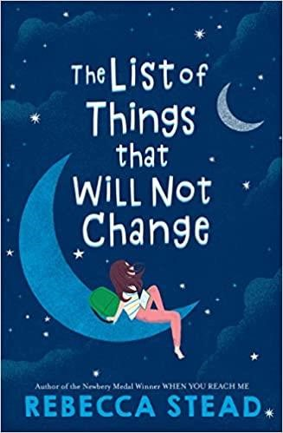 | At a time when everything is changing for Bea and her family, the important things will always stay the same. A soon-to-be classic by the Newbery Award-winning author of When You Reach Me.  After her parents' divorce, Bea's life became different in many ways. But she can always look back at the list she keeps in her green notebook to remember the things that will stay the same. The first and most important: Mom and Dad will always love Bea, and each other.  When Dad tells Bea that he and his boyfriend, Jesse, are getting married, Bea is thrilled. Bea loves Jesse, and when he and Dad get married, she'll finally (finally!) have what she's always wanted--a sister. Even though she's never met Jesse's daughter, Sonia, Bea is sure that they'll be "just like sisters anywhere." As the wedding day approaches, Bea will learn that making a new family brings questions, surprises, and joy, and readers will discover why the New York Times called Rebecca Stead a "writer of great feeling."  Available in print, ebook, and audio format at the Fresno County Public Library  Muaj cov ntawv luam tawm thiab ebook tawm ntawm Fresno County Lub Tsev Qiv Ntawv
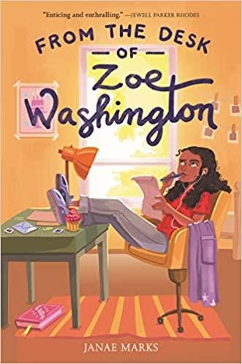 | From debut author Janae Marks comes a captivating story full of heart, as one courageous girl questions assumptions, searches for the truth, and does what she believes is right—even in the face of great opposition.  Zoe Washington isn’t sure what to write. What does a girl say to the father she’s never met, hadn’t heard from until his letter arrived on her twelfth birthday, and who’s been in prison for a terrible crime? A crime he says he never committed. Could Marcus really be innocent? Zoe is determined to uncover the truth. Even if it means hiding his letters and her investigation from the rest of her family. Everyone else thinks Zoe’s worrying about doing a good job at her bakery internship and proving to her parents that she’s worthy of auditioning for Food Network’s Kids Bake Challenge. But with bakery confections on one part of her mind, and Marcus’s conviction weighing heavily on the other, this is one recipe Zoe doesn’t know how to balance. The only thing she knows to be true: Everyone lies.  Available in print and ebook format at the Fresno County Public Library  Muaj cov ntawv luam tawm thiab ebook tawm ntawm Fresno County Lub Tsev Qiv Ntawv
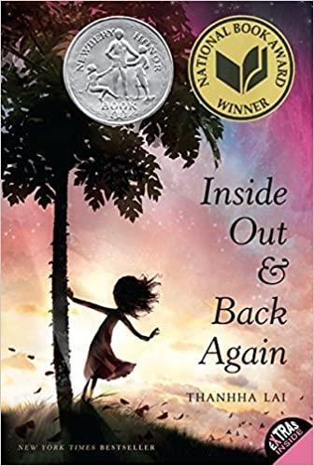 | #1 New York Times bestseller; Newbery Honor Book; Winner of the National Book Award  Inspired by the author's childhood experience as a refugee—fleeing Vietnam after the Fall of Saigon and immigrating to Alabama—this coming-of-age debut novel told in verse has been celebrated for its touching child's-eye view of family and immigration.  Hà has only ever known Saigon: the thrills of its markets, the joy of its traditions, and the warmth of her friends close by. But now the Vietnam War has reached her home. Hà and her family are forced to flee as Saigon falls, and they board a ship headed toward hope—toward America.  Available in print, ebook, and audio format at the Fresno County Public Library  Muaj cov ntawv luam tawm thiab ebook tawm ntawm Fresno County Lub Tsev Qiv Ntawv

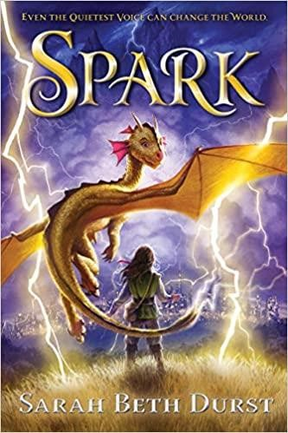 | When a shy girl and her dragon-like companion discover their country’s idyllic weather comes at a steep—and secret—cost, they recruit fellow students to defy authority and attempt to spread the truth.  Storm beasts and their guardians create perfect weather every day, and Mina longs for a storm beast of her own. But when the gentle girl bonds with a lightning beast—a creature of fire and chaos—everyone’s certain it’s a mistake. Everyone but Mina and the beast himself, Pixit. Quickly enrolled in lightning school, Mina struggles to master a guardian’s skills, and she discovers that her country's weather comes at a devastating cost—a cost powerful people wish to hide. Mina’s never been the type to speak out, but someone has to tell the truth, and, with Pixit’s help, she resolves to find a way to be heard.  Available in print and ebook format at the Fresno County Public Library  Muaj cov ntawv luam tawm thiab ebook tawm ntawm Fresno County Lub Tsev Qiv Ntawv
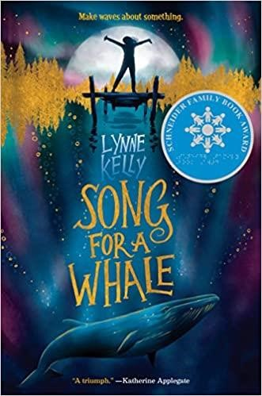 | In the spirit of modern-day classics like Fish in a Tree and Counting by 7s comes the Schneider Family Book Award-winning story of a deaf girl's connection to a whale whose song can't be heard by his species, and the journey she takes to help him.  From fixing the class computer to repairing old radios, twelve-year-old Iris is a tech genius. But she's the only deaf person in her school, so people often treat her like she's not very smart. If you've ever felt like no one was listening to you, then you know how hard that can be. When she learns about Blue 55, a real whale who is unable to speak to other whales, Iris understands how he must feel. Then she has an idea: she should invent a way to "sing" to him! But he's three thousand miles away. How will she play her song for him?  Full of heart and poignancy, this affecting story by sign language interpreter Lynne Kelly shows how a little determination can make big waves.
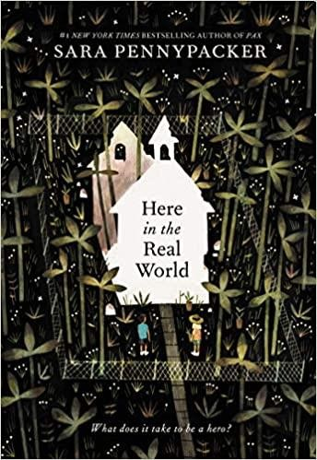 | From the author of the highly acclaimed, New York Times bestselling novel Pax comes a gorgeous and moving middle grade novel that is an ode to introverts, dreamers, and misfits everywhere.  Ware can’t wait to spend summer “off in his own world”—dreaming of knights in the Middle Ages and generally being left alone. But then his parents sign him up for dreaded Rec camp, where he must endure Meaningful Social Interaction and whatever activities so-called “normal” kids do. On his first day Ware meets Jolene, a tough, secretive girl planting a garden in the rubble of an abandoned church next to the camp. Soon he starts skipping Rec, creating a castlelike space of his own in the church lot.  Jolene scoffs, calling him a dreamer—he doesn’t live in the “real world” like she does. As different as Ware and Jolene are, though, they have one thing in common: for them, the lot is a refuge. But when their sanctuary is threatened, Ware looks to the knights’ Code of Chivalry: Thou shalt do battle against unfairness wherever faced with it. Thou shalt be always the champion of the Right and Good—and vows to save the lot.But what does a hero look like in real life? And what can two misfit kids do?  Available in print, ebook, and audio format at the Fresno County Public Library  Muaj cov ntawv luam tawm thiab ebook tawm ntawm Fresno County Lub Tsev Qiv Ntawv

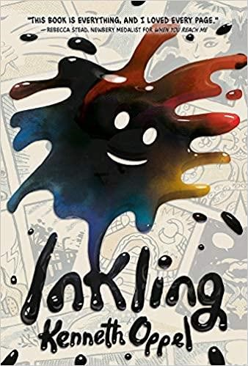 | Brilliantly funny, highly illustrated story about how a little ink splot changes a family forever.  The Rylance family is stuck. Dad's got writer's block. Ethan promised to illustrate a group project at school--even though he can't draw. Sarah's still pining for a puppy. And they all miss Mom. Enter Inkling. Inkling begins life in Mr. Rylance's sketchbook. But one night the ink of his drawings runs together--and then leaps off the page! This small burst of creativity is about to change everything. Ethan finds him first. Inkling has absorbed a couple chapters of his math book--not good--and the story he's supposed to be illustrating for school--also not good. But Inkling's also started drawing the pictures to go with the story--which is amazing! It's just the help Ethan was looking for! Inkling helps the rest of the family too--for Sarah he's a puppy. And for Dad he's a spark of ideas for a new graphic novel. It's exactly what they all want. It's not until Inkling goes missing that this family has to face the larger questions of what they--and Inkling-truly need.  Available in print, ebook, and audio format at the Fresno County Public Library  Muaj cov ntawv luam tawm thiab ebook tawm ntawm Fresno County Lub Tsev Qiv Ntawv
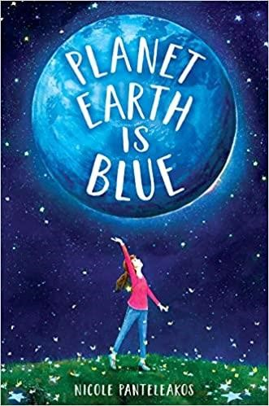 | Twelve-year-old Nova is eagerly awaiting the launch of the space shuttle Challenger--it's the first time a teacher is going into space, and kids across America will watch the event on live TV in their classrooms. Nova and her big sister, Bridget, share a love of astronomy and the space program. They planned to watch the launch together. But Bridget has disappeared, and Nova is in a new foster home.  While foster families and teachers dismiss Nova as severely autistic and nonverbal, Bridget understands how intelligent and special Nova is, and all that she can't express. As the liftoff draws closer, Nova's new foster family and teachers begin to see her potential, and for the first time, she is making friends without Bridget. But every day, she's counting down to the launch, and to the moment when she'll see Bridget again. Because as Bridget said, "No matter what, I'll be there. I promise."  Available in print and audio format at the Fresno County Public Library  Muaj cov ntawv luam tawm thiab suab ua qauv nyob rau ntawm Fresno County Public Library
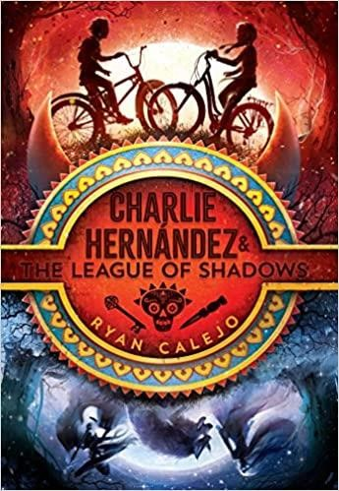 | The Lightning Thief meets the Story Thieves series in this middle grade fantasy inspired by  Hispanic folklore, legends, and myths from the Iberian Peninsula and Central and South America.  Charlie Hernández has always been proud of his Latin American heritage. He loves the culture, the art, and especially the myths. Thanks to his abuela’s stories, Charlie possesses an almost encyclopedic knowledge of the monsters and ghouls who have spent the last five hundred years haunting the imaginations of children all across the Iberian Peninsula, as well as Central and South America. Soon, Charlie finds himself in the middle of an ancient battle between La Liga, a secret society of legendary mythological beings sworn to protect the Land of the Living, and La Mano Peluda (a.k.a. the Hairy Hand), a cabal of evil spirits determined to rule mankind. With only the help of his lifelong crush, Violet Rey, and his grandmother’s stories to guide him, Charlie must navigate a world where monsters and brujas rule and things he couldn’t possibly imagine go bump in the night.  First in a series. Available in print at the Fresno County Public Library  Muaj cov ntawv luam tawm hauv Fresno County Chaw Qiv Ntawv

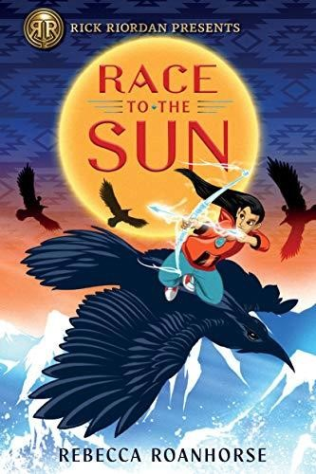 | Lately, seventh grader Nizhoni Begay has been able to detect monsters, like that man in the fancy suit who was in the bleachers at her basketball game. Turns out he's Mr. Charles, her dad's new boss at the oil and gas company, and he's alarmingly interested in Nizhoni and her brother, Mac, their Navajo heritage, and the legend of the Hero Twins. Nizhoni knows he's a threat, but her father won't believe her. When Dad disappears the next day, leaving behind a message that says "Run!", the siblings and Nizhoni's best friend, Davery, are thrust into a rescue mission that can only be accomplished with the help of Diné Holy People, all disguised as quirky characters. Their aid will come at a price: the kids must pass a series of trials in which it seems like nature itself is out to kill them. If Nizhoni, Mac, and Davery can reach the House of the Sun, they will be outfitted with what they need to defeat the ancient monsters Mr. Charles has unleashed. But it will take more than weapons for Nizhoni to become the hero she was destined to be...  Timeless themes such as the importance of family and respect for the land resonate in this funny, fast-paced, and exciting quest adventure set in the American Southwest.  Available in print, ebook and audio format at the Fresno County Public Library  Muaj cov ntawv luam tawm thiab ebook tawm ntawm Fresno County Lub Tsev Qiv Ntawv
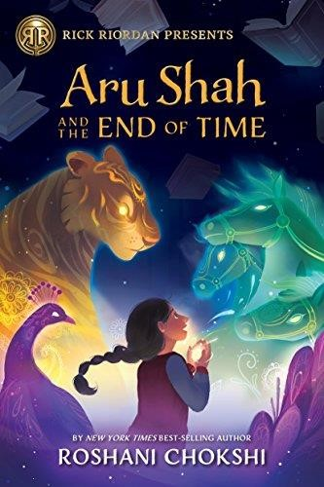 | Best-selling author Rick Riordan introduces this adventure by Roshani Chokshi about twelveyear-old Aru Shah, who has a tendency to stretch the truth in order to fit in at school. While her classmates are jetting off to family vacations in exotic locales, she'll be spending her autumn break at home, in the Museum of Ancient Indian Art and Culture, waiting for her mom to return from her latest archeological trip. Is it any wonder that Aru makes up stories about being royalty, traveling to Paris, and having a chauffeur? One day, three schoolmates show up at Aru's doorstep to catch her in a lie. They don't believe her claim that the museum's Lamp of Bharata is cursed, and they dare Aru to prove it. Just a quick light, Aru thinks. Then she can get herself out of this mess and never ever fib again. But lighting the lamp has dire consequences. She unwittingly frees the Sleeper, an ancient demon whose duty it is to awaken the God of Destruction. Her classmates and beloved mother are frozen in time, and it's up to Aru to save them. The only way to stop the demon is to find the reincarnations of the five legendary Pandava brothers, protagonists of the Hindu epic poem, the Mahabharata, and journey through the Kingdom of Death. But how is one girl in Spider-Man pajamas supposed to do all that?  First in a series. Available in print, ebook and audio format at the Fresno County Public Library  Muaj cov ntawv luam tawm thiab ebook tawm ntawm Fresno County Lub Tsev Qiv Ntawv
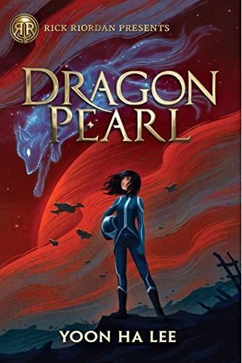 | This sci-fi adventure with the underpinnings of Korean mythology will transport you to a world far beyond your imagination.  Rick Riordan Presents Yoon Ha Lee's space opera about thirteen-year-old Min, who comes from a long line of fox spirits. But you'd never know it by looking at her. To keep the family safe, Min's mother insists that none of them use any fox-magic, such as Charm or shape-shifting. They must appear human at all times. Min feels hemmed in by the household rules and resents the endless chores, the cousins who crowd her, and the aunties who judge her. She would like nothing more than to escape Jinju, her neglected, dust-ridden, and impoverished planet. She's counting the days until she can follow her older brother, Jun, into the Space Forces and see more of the Thousand Worlds.  When word arrives that Jun is suspected of leaving his post to go in search of the Dragon Pearl, Min knows that something is wrong. Jun would never desert his battle cruiser, even for a mystical object rumored to have tremendous power. She decides to run away to find him and clear his name. Min's quest will have her meeting gamblers, pirates, and vengeful ghosts. It will involve deception, lies, and sabotage. She will be forced to use more fox-magic than ever before, and to rely on all of her cleverness and bravery. The outcome may not be what she had hoped, but it has the potential to exceed her wildest dreams.  Available in print, ebook, and audio format at the Fresno County Public Library  Muaj cov ntawv luam tawm, ebook, thiab cov suab nyob ntawm Fresno County Public Library

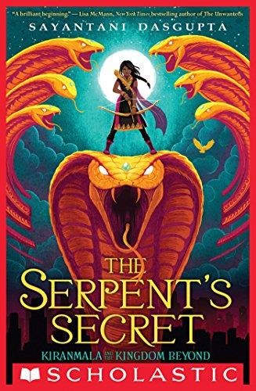 | Meet Kiranmala: Interdimensional Demon Slayer (Only she doesn't know it yet.)  On the morning of her twelfth birthday, Kiranmala is just a regular sixth grader living in Parsippany, New Jersey...until her parents mysteriously vanish and a drooling rakkhosh demon slams through her kitchen, determined to eat her alive. Turns out there might be some truth to her parents' fantastical stories-like how Kiranmala is a real Indian princess and how she comes from a secret place not of this world. To complicate matters, two crush-worthy princes ring her doorbell, insisting they've come to rescue her. Suddenly, Kiran is swept into another dimension full of magic, winged horses, moving maps, and annoying, talking birds. There she must solve riddles and battle demons all while avoiding the Serpent King of the underworld and the Rakkhoshi Queen in order to find her parents and basically save New Jersey, her entire world, and everything beyond it...  First in a series.  Available in print, ebook, and audio format at the Fresno County Public Library  Muaj cov ntawv luam tawm, ebook, thiab cov suab nyob ntawm Fresno County Public Library
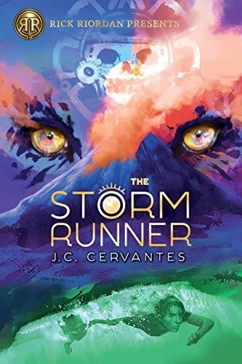 | A contemporary adventure based on Maya mythology from Rick Riordan Presents and New York Times bestselling author J. C. Cervantes.  Zane has always enjoyed exploring the dormant volcano near his home in New Mexico, even though hiking it is challenging. He'd much rather hang out there with his dog, Rosie, than go to middle school, where kids call him Sir Limps a Lot, McGimpster, or Uno--for his one good leg. What Zane doesn't know is that the volcano is a gateway to another world and he is at the center of a powerful prophecy. A new girl at school, Brooks, informs him that he's destined to release an evil god from the ancient Maya relic he is imprisoned in--unless she can find and remove it first. Together they return to the volcano, where all kinds of crazy happens. Brooks turns into a hawk, a demon attacks them in a cave, and Rosie gives her all while trying to protect Zane. When Zane decides to save his dog no matter the cost, he is thrust into an adventure full of surprising discoveries, dangerous secrets, and an all-out war between the gods, one of whom happens to be his father. To survive, Zane will have to become the Storm Runner. But how can he run when he can't even walk well without a cane?  First in a series. Available in print, ebooks, and audio at the Fresno County Public Library  Muaj cov ntawv luam tawm, ebook, thiab cov suab nyob ntawm Fresno County Public Library
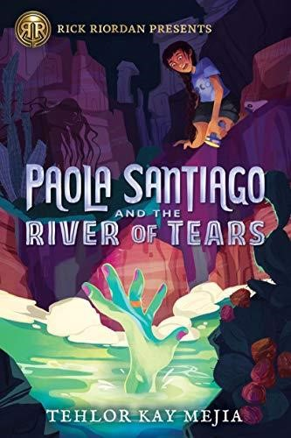 | Space-obsessed 12-year-old Paola Santiago and her two best friends, Emma and Dante, know the rule: Stay away from the river. It's all they've heard since a schoolmate of theirs drowned a year ago. Pao is embarrassed to admit that she has been told to stay away for even longer than that, because her mother is constantly warning her about La Llorona, the wailing ghost woman who wanders the banks of the Gila at night, looking for young people to drag into its murky depths.Hating her mother's humiliating superstitions and knowing that she and her friends would never venture into the water, Pao organizes a meet-up to test out her new telescope near the Gila, since it's the best stargazing spot. But when Emma never arrives and Pao sees a shadowy figure in the reeds, it seems like maybe her mom was right. . . .Pao has always relied on hard science to make sense of the world, but to find her friend she will have to enter the world of her nightmares, which includes unnatural mist, mind-bending monsters, and relentless spirits controlled by a terrifying force that defies both logic and legend.  Available in print, ebook, and audio format at the Fresno County Public Library  Muaj cov ntawv luam tawm, ebook, thiab cov suab nyob ntawm Fresno County Public Library

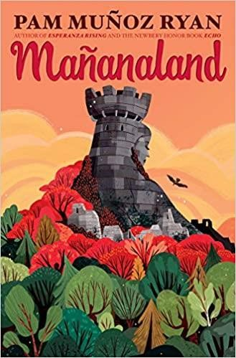 | Maximiliano Córdoba loves stories, especially the legend Buelo tells him about a mythical gatekeeper who can guide brave travelers on a journey into tomorrow. If Max could see tomorrow, he would know if he'd make Santa Maria's celebrated fútbol team and whether he'd ever meet his mother, who disappeared when he was a baby. He longs to know more about her, but Papá won't talk. So when Max uncovers a buried family secret--involving an underground network of guardians who lead people fleeing a neighboring country to safety--he decides to seek answers on his own. With a treasured compass, a mysterious stone rubbing, and Buelo's legend as his only guides, he sets out on a perilous quest to discover if he is true of heart and what the future holds.  This timeless tale of struggle, hope, and the search for tomorrow has much to offer today about compassion and our shared humanity.  Available in print, ebook, and audio format at the Fresno County Public Library  Muaj cov ntawv luam tawm, ebook, thiab cov suab nyob ntawm Fresno County Public Library
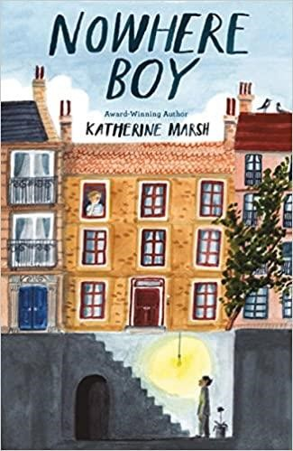 | Set against the backdrop of the Syrian refugee crisis, award-winning author of Jepp, Who Defied the Stars Katherine Marsh delivers a gripping, heartwarming story of resilience, friendship and everyday heroes.  Fourteen-year-old Ahmed is stuck in a city that wants nothing to do with him. Newly arrived in Brussels, Belgium, Ahmed fled a life of uncertainty and suffering in Aleppo, Syria, only to lose his father on the perilous journey to the shores of Europe. Now Ahmed’s struggling to get by on his own, but with no one left to trust and nowhere to go, he’s starting to lose hope. Then he meets Max, a thirteen-year-old American boy from Washington, D.C. Lonely and homesick, Max is struggling at his new school and just can’t seem to do anything right. But with one startling discovery, Max and Ahmed’s lives collide and a friendship begins to grow. Together, Max and Ahmed will defy the odds, learning from each other what it means to be brave and how hope can change your destiny.  Available in print at the Fresno County Public Library  Muaj cov ntawv luam tawm hauv Fresno County Chaw Qiv Ntawv
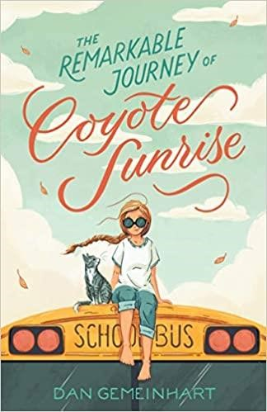 | Five years.  That's how long Coyote and her dad, Rodeo, have lived on the road in an old school bus, crisscrossing the nation.It's also how long ago Coyote lost her mom and two sisters in a car crash. Coyote hasn’t been home in all that time, but when she learns that the park in her old neighborhood is being demolished―the very same park where she, her mom, and her sisters buried a treasured memory box―she devises an elaborate plan to get her dad to drive 3,600 miles back to Washington state in four days...without him realizing it.  Along the way, they'll pick up a strange crew of misfit travelers. Lester has a lady love to meet. Salvador and his mom are looking to start over. Val needs a safe place to be herself. And then there's Gladys...Over the course of thousands of miles, Coyote will learn that going home can sometimes be the hardest journey of all...but that with friends by her side, she just might be able to turn her “once upon a time” into a “happily ever after.”  Available in print, ebook, and audio format at the Fresno County Public Library  Muaj cov ntawv luam tawm, ebook, thiab cov suab nyob ntawm Fresno County Public Library

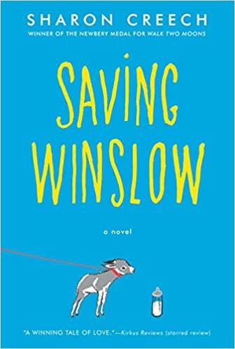 | Perfect for fans of Charlotte’s Web and The One and Only Ivan, Saving Winslow is an uplifting modern classic in the making about a young boy who befriends an ailing newborn donkey and nurses him back to health, from New York Times bestseller and Newbery Medal winner Sharon Creech.  Louie doesn't have the best luck when it comes to nurturing small creatures. So when his father brings home a sickly newborn mini donkey, he's determined to save him. He names him  Winslow. Taking care of him helps Louie feel closer to his brother, Gus, who is far, far away in the army. Everyone worries that Winslow won't survive, especially Louie’s quirky new friend, Nora, who has experienced loss of her own. But as Louie's bond with Winslow grows, surprising and life-altering events prove that this fragile donkey is stronger than anyone could have imagined.  Available in print, ebook, and audio format at the Fresno County Public Library  Muaj cov ntawv luam tawm, ebook, thiab cov suab nyob ntawm Fresno County Public Library
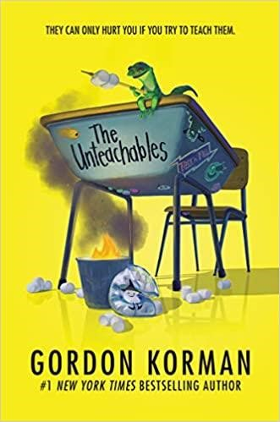 | A hilarious new middle grade novel from beloved and bestselling author Gordon Korman about what happens when the worst class of kids in school is paired with the worst teacher.  The Unteachables are a notorious class of misfits, delinquents, and academic train wrecks. Like Aldo, with anger management issues; Parker, who can’t read; Kiana, who doesn’t even belong in the class—or any class; and Elaine (rhymes with pain). The Unteachables have been removed from the student body and isolated in room 117. Their teacher is Mr. Zachary Kermit, the most burned-out teacher in all of Greenwich. He was once a rising star, but his career was shattered by a cheating scandal that still haunts him. After years of phoning it in, he is finally one year away from early retirement. But the superintendent has his own plans to torpedo that idea—and it involves assigning Mr. Kermit to the Unteachables. The Unteachables never thought they’d find a teacher who had a worse attitude than they did. And Mr. Kermit never thought he would actually care about teaching again. Over the course of a school year, though, room 117 will experience mayhem, destruction—and maybe even a shot at redemption.  Available in print, ebook, and audio format at the Fresno County Public Library  Muaj cov ntawv luam tawm, ebook, thiab cov suab nyob ntawm Fresno County Public Library
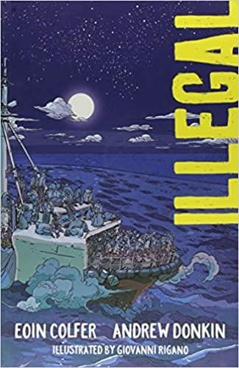 | 2019 Excellence in Graphic Literature Award Winner; American Library Association Notable Book 2019; 2019 YALSA Top 10 Graphic Novels for Teens  A powerfully moving, award-winning graphic novel that explores the current plight of undocumented immigrants from New York Times bestselling author Eoin Colfer and the team behind the Artemis Fowl graphic novels.  How can a human being be illegal for simply existing? Ebo is alone. His brother, Kwame, has disappeared, and Ebo knows it can only be to attempt the hazardous journey to Europe, and a better life―the same journey their sister set out on months ago. But Ebo refuses to be left behind in Ghana. He sets out after Kwame and joins him on the quest to reach Europe. Ebo's epic journey takes him across the Sahara Desert to the dangerous streets of Tripoli, and finally out to the merciless sea. But with every step he holds on to his hope for a new life, and a reunion with his family. An achingly poignant tale for learning about immigration and current global issues. This book is fiction, but it is based on a very real and terrible journey. There are young people who have lived this, and it is a story those young people want us to know about.  Available in print, ebook, and audio format at the Fresno County Public Library  Muaj cov ntawv luam tawm, ebook, thiab cov suab nyob ntawm Fresno County Public Library

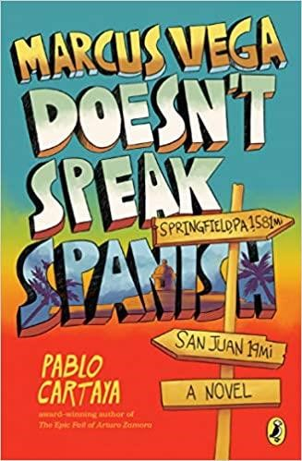 | Marcus Vega is six feet tall, 180 pounds, and the owner of a premature mustache. When you look like this and you're only in the eighth grade, you're both a threat and a target.  After a fight at school leaves Marcus facing suspension, Marcus's mom decides it's time for a change of environment. She takes Marcus and his younger brother to Puerto Rico to spend a week with relatives they don't remember or have never met. But Marcus can't focus knowing that his father--who walked out of their lives ten years ago--is somewhere on the island.  So begins Marcus's incredible journey, a series of misadventures that take him all over Puerto Rico in search of his elusive namesake. Marcus doesn't know if he'll ever find his father, but what he ultimately discovers changes his life. And he even learns a bit of Spanish along the way.  Available in print and ebook format at the Fresno County Public Library  Muaj cov ntawv luam tawm, ebook, thiab cov suab nyob ntawm Fresno County Public Library
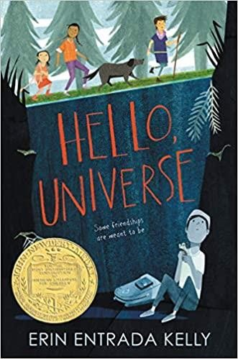 | Winner of the Newbery Medal  Hello, Universe is a funny and poignant neighborhood story about unexpected friendships. Told from four intertwining points of view—two boys and two girls—the novel celebrates bravery, being different, and finding your inner bayani (hero).  In one day, four lives weave together in unexpected ways. Virgil Salinas is shy and kind hearted and feels out of place in his crazy-about-sports family. Valencia Somerset, who is deaf, is smart, brave, and secretly lonely, and she loves everything about nature. Kaori Tanaka is a selfproclaimed psychic, whose little sister, Gen, is always following her around. And Chet Bullens wishes the weird kids would just stop being so different so he can concentrate on basketball.They aren’t friends, at least not until Chet pulls a prank that traps Virgil and his pet guinea pig at the bottom of a well. This disaster leads Kaori, Gen, and Valencia on an epic quest to find missing Virgil. Through luck, smarts, bravery, and a little help from the universe, a rescue is performed, a bully is put in his place, and friendship blooms.  Available in print, ebook, and audio format at the Fresno County Public Library  Muaj cov ntawv luam tawm, ebook, thiab cov suab nyob ntawm Fresno County Public Library
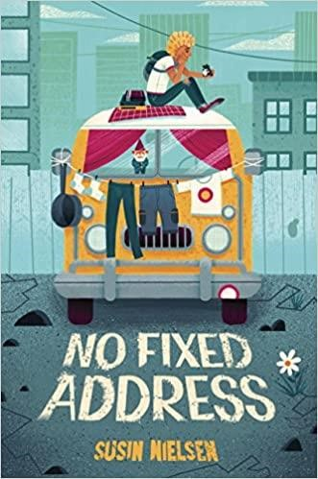 | A touching and funny middle-grade story about family, friendship, and growing up when you're one step away from homelessness.  Twelve-and-three-quarter-year-old Felix Knutsson has a knack for trivia. His favorite game show is Who What Where When; he even named his gerbil after the host. Felix's mom, Astrid, is loving but can't seem to hold on to a job. So when they get evicted from their latest shabby apartment, they have to move into a van. Astrid swears him to secrecy; he can't tell anyone about their living arrangement, not even Dylan and Winnie, his best friends at his new school. If he does, she warns him, he'll be taken away from her and put in foster care.  Available in print and audio format at the Fresno County Public Library  Muaj cov ntawv luam tawm thiab suab ua qauv nyob rau ntawm Fresno County Public Library

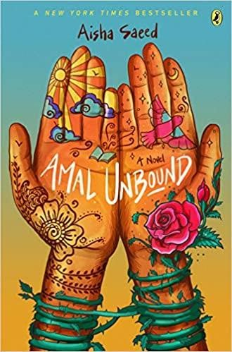 | A New York Times Bestseller  Amal has big dreams, until a nightmarish encounter . . .Twelve-year-old Amal's dream of becoming a teacher one day is dashed in an instant when she accidentally insults a member of her Pakistani village's ruling family. As punishment for her behavior, she is forced to leave her heartbroken family behind and go work at their estate. Amal is distraught but has faced setbacks before. So she summons her courage and begins navigating the complex rules of life as a servant, with all its attendant jealousies and pecking-order woes. Most troubling, though, is Amal's increasing awareness of the deadly measures the Khan family will go to in order to stay in control. It's clear that their hold over her village will never loosen as long as everyone is too afraid to challenge them--so if Amal is to have any chance of ensuring her loved ones' safety and winning back her freedom, she must find a way to work with the other servants to make it happen.  Available in print, ebook, and audio format at the Fresno County Public Library  Muaj cov ntawv luam tawm, ebook, thiab cov suab nyob ntawm Fresno County Public Library
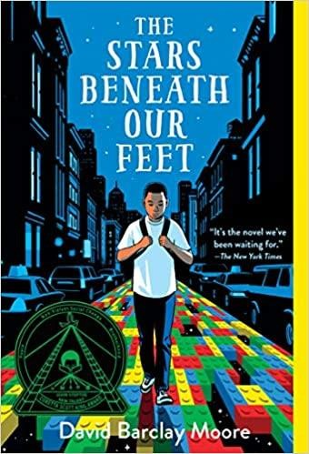 | It’s Christmas Eve in Harlem, but twelve-year-old Lolly Rachpaul and his mom aren’t celebrating. They’re still reeling from his older brother’s death in a gang-related shooting just a few months earlier. Then Lolly’s mother’s girlfriend brings him a gift that will change everything: two enormous bags filled with Legos. Lolly’s always loved Legos, and he prides himself on following the kit instructions exactly. Now, faced with a pile of building blocks and no instructions, Lolly must find his own way forward. His path isn’t clear—and the pressure to join a “crew,” as his brother did, is always there. When Lolly and his friend are beaten up and robbed, joining a crew almost seems like the safe choice. But building a fantastical Lego city at the community center provides Lolly with an escape—and an unexpected bridge back to the world.  David Barclay Moore paints a powerful portrait of a boy teetering on the edge—of adolescence, of grief, of violence—and shows how Lolly’s inventive spirit helps him build a life with firm foundations and open doors.  Available in print, ebook, and audio format at the Fresno County Public Library  Muaj cov ntawv luam tawm, ebook, thiab cov suab nyob ntawm Fresno County Public Library
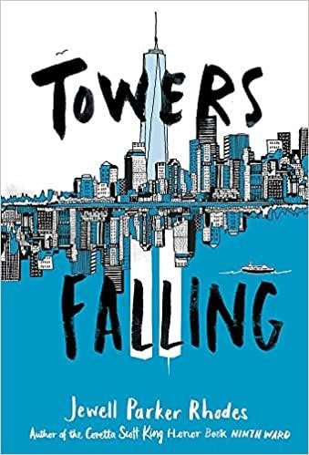 | From award-winning author Jewell Parker Rhodes comes a powerful novel set fifteen years after the 9/11 attacks in a classroom of students who cannot remember the event but live through the aftermath of its cultural shift.  When her fifth-grade teacher hints that a series of lessons about home and community will culminate with one big answer about two tall towers once visible outside their classroom window, Dèja can't help but feel confused. She sets off on a journey of discovery, with new friends Ben and Sabeen by her side. But just as she gets closer to answering big questions about who she is, what America means, and how communities can grow (and heal), she uncovers new questions, too. Like, why does Pop get so angry when she brings up anything about the towers?  Available in print, ebook, and audio format at the Fresno County Public Library  Muaj cov ntawv luam tawm, ebook, thiab cov suab nyob ntawm Fresno County Public Library

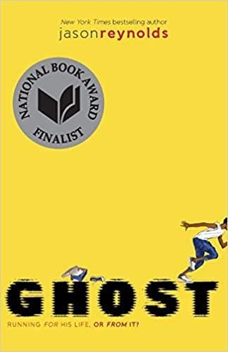 | National Book Award Finalist for Young People’s Literature; Nominated as one of America’s bestloved novels by PBS’s The Great American Read.  Ghost wants to be the fastest sprinter on his elite middle school track team, but his past is slowing him down in this first electrifying novel of the acclaimed Track series from Coretta Scott King/John Steptoe Award–winning author Jason Reynolds.  Ghost. Lu. Patina. Sunny. Four kids from wildly different backgrounds with personalities that are explosive when they clash. But they are also four kids chosen for an elite middle school track team—a team that could qualify them for the Junior Olympics if they can get their acts together. They all have a lot to lose, but they also have a lot to prove, not only to each other, but to themselves.  First in a series  Available in print, ebook, and audio format at the Fresno County Public Library  Muaj cov ntawv luam tawm, ebook, thiab cov suab nyob ntawm Fresno County Public Library
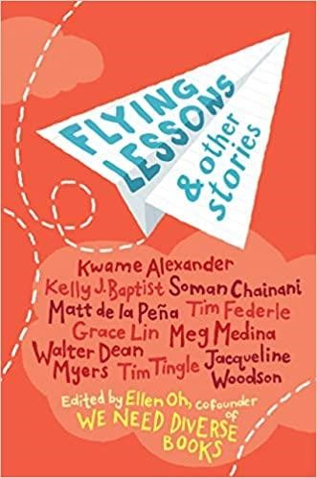 | "Will resonate with any kid who's ever felt different—which is to say, every kid." —Time  Great stories take flight in this adventurous middle-grade anthology crafted by ten of the most recognizable and diverse authors writing today. Newbery Medalist Kwame Alexander delivers a story in-verse about a boy who just might have magical powers; National Book Award winner Jacqueline Woodson spins a tale of friendship against all odds; and Meg Medina uses wet paint to color in one girl’s world with a short story that inspired her Newbery award-winner Merci Suárez Changes Gear. Plus, seven more bold voices that bring this collection to new heights with tales that challenge, inspire, and celebrate the unique talents within us all.  Available in print, ebook, and audio format at the Fresno County Public Library  Muaj cov ntawv luam tawm, ebook, thiab cov suab nyob ntawm Fresno County Public Library
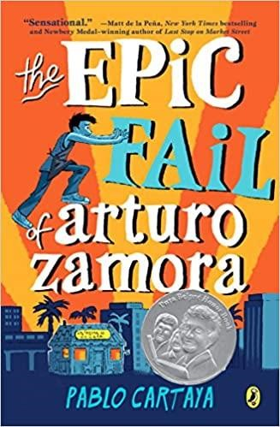 | A 2018 Pura Belpré Author Honor Book  Save the restaurant. Save the town. Get the girl. Make Abuela proud. Can thirteen-year-old Arturo Zamora do it all or is he in for a BIG, EPIC FAIL? For Arturo, summertime in Miami means playing basketball until dark, sipping mango smoothies, and keeping cool under banyan trees. And maybe a few shifts as junior lunchtime dishwasher at Abuela’s restaurant. Maybe. But this summer also includes Carmen, a poetry enthusiast who moves into Arturo’s apartment complex and turns his stomach into a deep fryer. He almost doesn’t notice the smarmy land developer who rolls into town and threatens to change it. Arturo refuses to let his family and community go down without a fight, and as he schemes with Carmen, Arturo discovers the power of poetry and protest through untold family stories and the work of José Martí. Funny and poignant, The Epic Fail of Arturo Zamora is the vibrant story of a family, a striking portrait of a town, and one boy's quest to save both.  Available in print and ebook format at the Fresno County Public Library  Muaj cov ntawv luam tawm, ebook, thiab cov suab nyob ntawm Fresno County Public Library

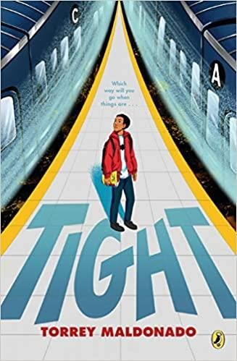 | A Washington Post Best Children's Book of 2018  Tight: Lately Bryan's been feeling it in all kinds of ways. He knows what's tight for him in a good way--reading comics, drawing superheroes, and hanging out with no drama. But drama's hard to escape where he's from, and that gets him wound up tight. And now Bryan's new friend Mike is challenging him to have fun in ways that are crazy risky. At first, it's a rush following Mike, hopping turnstiles, subway surfing, and getting into all kinds of trouble. But Bryan never feels right acting wrong. So which way will he go when he understands that drama is so not his style? Fortunately his favorite comic heroes shed light on his dilemma, reminding him that he has power--the power to choose his friends and to stand up for what he believes is right . . .  Torrey Maldonado delivers a fast-paced, insightful, dynamic story. Readers will connect with Bryan's journey as he navigates a tough world with a heartfelt desire for a different life.  Available in print at the Fresno County Public Library  Muaj cov ntawv luam tawm hauv Fresno County Chaw Qiv Ntawv
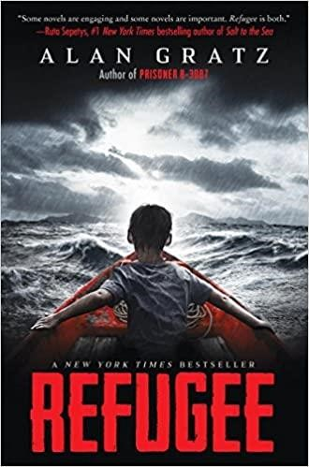 | New York Times bestseller  JOSEF is a Jewish boy living in 1930s Nazi Germany. With the threat of concentration camps looming, he and his family board a ship bound for the other side of the world... ISABEL is a Cuban girl in 1994. With riots and unrest plaguing her country, she and her family set out on a raft, hoping to find safety in America...MAHMOUD is a Syrian boy in 2015. With his homeland torn apart by violence and destruction, he and his family begin a long trek toward Europe...  All three kids go on harrowing journeys in search of refuge. All will face unimaginable dangers -- from drownings to bombings to betrayals. But there is always the hope of tomorrow. And although Josef, Isabel, and Mahmoud are separated by continents and decades, shocking connections will tie their stories together in the end. This action-packed novel tackles topics both timely and timeless: courage, survival, and the quest for home.  Available in print, ebook, and audio format at the Fresno County Public Library  Muaj cov ntawv luam tawm, ebook, thiab cov suab nyob ntawm Fresno County Public Library
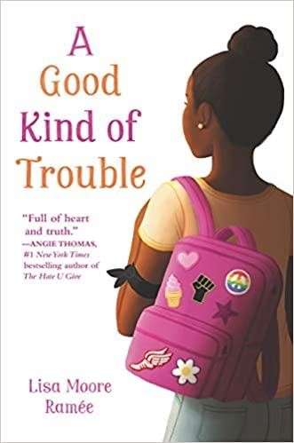 | From debut author Lisa Moore Ramée comes this funny and big-hearted debut middle grade novel about friendship, family, and standing up for what’s right, perfect for fans of Angie Thomas’s The Hate U Give and the novels of Renée Watson and Jason Reynolds.  Twelve-year-old Shayla is allergic to trouble. All she wants to do is to follow the rules. (Oh, and she’d also like to make it through seventh grade with her best friendships intact, learn to run track, and have a cute boy see past her giant forehead.) But in junior high, it’s like all the rules have changed. Now she’s suddenly questioning who her best friends are and some people at school are saying she’s not black enough. Wait, what? Shay’s sister, Hana, is involved in Black Lives Matter, but Shay doesn't think that's for her. After experiencing a powerful protest, though, Shay decides some rules are worth breaking. She starts wearing an armband to school in support of the Black Lives movement. Soon everyone is taking sides. And she is given an ultimatum. Shay is scared to do the wrong thing (and even more scared to do the right thing), but if she doesn't face her fear, she'll be forever tripping over the next hurdle. Now that’s trouble, for real.  Available in print, ebook, and audio format at the Fresno County Public Library  Muaj cov ntawv luam tawm, ebook, thiab cov suab nyob ntawm Fresno County Public Library

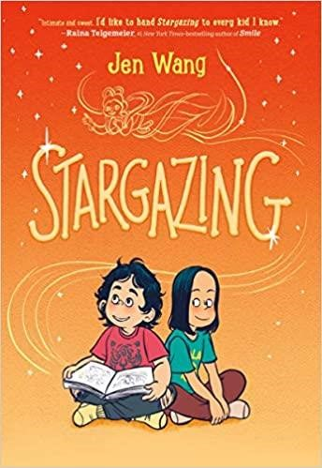 | Stargazing is a heartwarming middle-grade graphic novel in the spirit of Real Friends and El Deafo, from New York Times bestselling author-illustrator Jen Wang.  Moon is everything Christine isn't. She’s confident, impulsive, artistic . . . and though they both grew up in the same Chinese-American suburb, Moon is somehow unlike anyone Christine has ever known. But after Moon moves in next door, these unlikely friends are soon best friends, sharing their favorite music videos and painting their toenails when Christine's strict parents aren't around. Moon even tells Christine her deepest secret: that she has visions, sometimes, of celestial beings who speak to her from the stars. Who reassure her that earth isn't where she really belongs. Moon's visions have an all-too-earthly root, however, and soon Christine's best friend is in the hospital, fighting for her life. Can Christine be the friend Moon needs, now, when the sky is falling? Jen Wang draws on her childhood to paint a deeply personal yet wholly relatable friendship story that’s at turns joyful, heart-wrenching, and full of hope.  Available in print at the Fresno County Public Library  Muaj cov ntawv luam tawm hauv Fresno County Chaw Qiv Ntawv
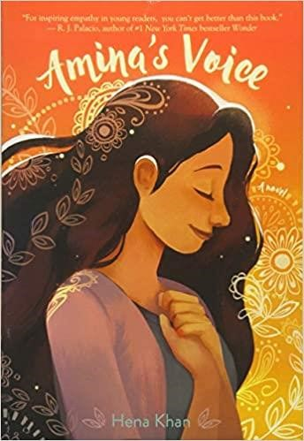 | A Washington Post Best Children’s Book of 2017  A Pakistani-American Muslim girl struggles to stay true to her family’s vibrant culture while simultaneously blending in at school after tragedy strikes her community.  Amina has never been comfortable in the spotlight. She is happy just hanging out with her best friend, Soojin. Except now that she’s in middle school everything feels different. Soojin is suddenly hanging out with Emily, one of the “cool” girls in the class, and even talking about changing her name to something more “American.” Does Amina need to start changing too? Or hiding who she is to fit in? While Amina grapples with these questions, she is devastated when her local mosque is vandalized. Amina’s Voice brings to life the joys and challenges of a young Pakistani-American and highlights the many ways in which one girl’s voice can help bring a diverse community together to love and support each other.  Available in print, ebook, and audio format at the Fresno County Public Library  Muaj cov ntawv luam tawm, ebook, thiab cov suab nyob ntawm Fresno County Public Library
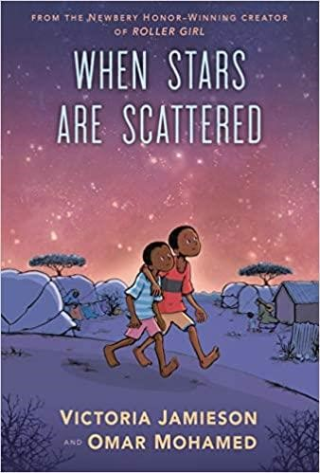 | Omar and his younger brother, Hassan, have spent most of their lives in Dadaab, a refugee camp in Kenya. Life is hard there: never enough food, achingly dull, and without access to the medical care Omar knows his nonverbal brother needs. So when Omar has the opportunity to go to school, he knows it might be a chance to change their future...but it would also mean leaving his brother, the only family member he has left, every day.  Heartbreak, hope, and gentle humor exist together in this graphic novel about a childhood spent waiting, and a young man who is able to create a sense of family and home in the most difficult of settings. It's an intimate, important, unforgettable look at the day-to-day life of a refugee, as told to New York Times Bestselling author/artist Victoria Jamieson by Omar Mohamed, the Somali man who lived the story.  Available in print, ebook and audio format at the Fresno County Public Library  Muaj cov ntawv luam tawm, ebook, thiab cov suab nyob ntawm Fresno County Public Library

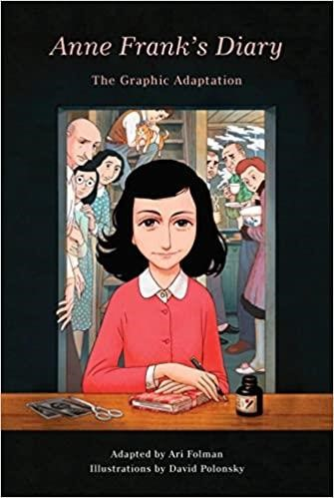 | A timeless story rediscovered by each new generation, The Diary of a Young Girl stands without peer. For both young readers and adults it continues to capture the remarkable spirit of Anne Frank, who for a time survived the worst horror the modern world has seen—and who remained triumphantly and heartbreakingly human throughout her ordeal.  Adapted by Ari Folman, illustrated by David Polonsky, and authorized by the Anne Frank  Foundation in Basel, this is the first graphic edition of The Diary and includes extensive quotation directly from the definitive edition. It remains faithful to the original, while the stunning illustrations interpret and add layers of visual meaning and immediacy to this classic work of Holocaust literature.  Available in print format at the Fresno County Public Library  Muaj cov ntawv luam tawm hauv Fresno County Chaw Qiv Ntawv
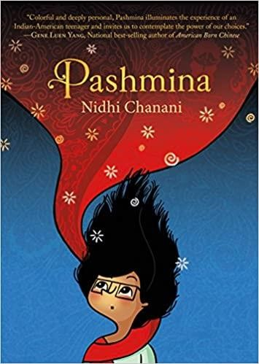 | Priyanka Das has so many unanswered questions: Why did her mother abandon her home in India years ago? What was it like there? And most importantly, who is her father, and why did her mom leave him behind? But Pri’s mom avoids these questions―the topic of India is permanently closed. For Pri, her mother's homeland can only exist in her imagination. That is, until she finds a mysterious pashmina tucked away in a forgotten suitcase. When she wraps herself in it, she is transported to a place more vivid and colorful than any guidebook or  Bollywood film. But is this the real India? And what is that shadow lurking in the background? To learn the truth, Pri must travel farther than she’s ever dared and find the family she never knew. In this heartwarming graphic novel debut, Nidhi Chanani weaves a tale about the hardship and self-discovery that is born from juggling two cultures and two worlds.  Available in print format at the Fresno County Public Library  Muaj cov ntawv luam tawm hauv Fresno County Chaw Qiv Ntawv
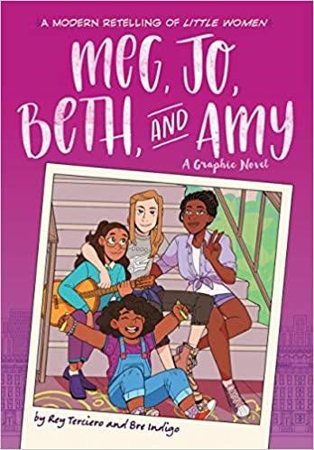 | Little Women with a twist: four sisters from a blended family experience the challenges and triumphs of life in NYC in this beautiful full-color graphic novel perfect for fans of Roller Girl and Smile.  Meg, Jo, Beth, and Amy are having a really tough year: with their father serving in the military overseas, they must work overtime to make ends meet...and each girl is struggling in her own way. Whether it's school woes, health issues, boy troubles, or simply feeling lost, the March sisters all need the same thing: support from each other. Only by coming together--and sharing lots of laughs and tears--will these four young women find the courage to discover who they truly are as individuals...and as a family.  Available in print and ebook format at the Fresno County Public Library  Muaj cov ntawv luam tawm thiab ebook tawm ntawm Fresno County Lub Tsev Qiv Ntawv

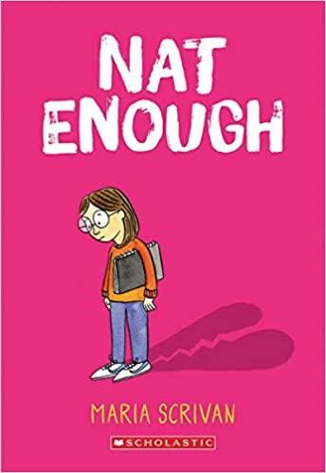 | New York Times bestseller  Making friends isn't easy, but losing them is even harder!  Natalie has never felt that she's enough -- athletic enough, stylish enough, or talented enough.  And on the first day of middle school, Natalie discovers that things are worse than she thought - now she's not even cool enough for her best friend, Lily! As Natalie tries to get her best friend back, she learns more about her true self and natural talents. If Natalie can focus on who she is rather than who she isn't, then she might realize she's more than enough, just the way she is.  Available in print and ebook format at the Fresno County Public Library  Muaj cov ntawv luam tawm thiab ebook tawm ntawm Fresno County Lub Tsev Qiv Ntawv
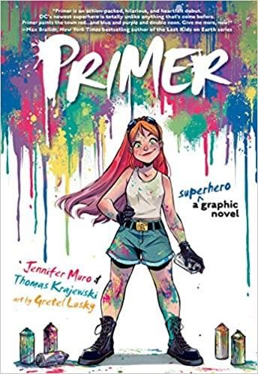 | Animation superstars Jennifer Muro and Thomas Krajewski introduce us to a brand-new superhero with a colorful array of superpowers! Thirteen-year-old Ashley Rayburn is an upbeat girl with a decidedly downbeat past. With a criminal father in prison, Ashley has bounced from foster home to foster home with trouble always finding her along the way. Finally settling in with loving and supportive foster parents, Ashley's world is turned upside down again when she stumbles upon a set of body paints that grant the wearer a multitude of superpowers. But the government agency that made those paints wants them back, and now she has to make hard choices to protect her new family while overcoming the shadows of the past.  Available in print format at the Fresno County Public Library  Muaj cov ntawv luam tawm hauv Fresno County Chaw Qiv Ntawv
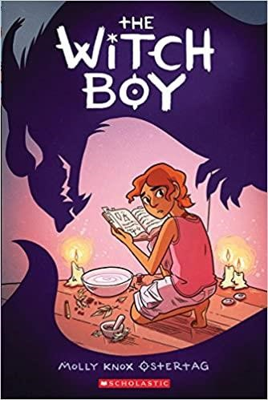 | In thirteen-year-old Aster's family, all the girls are raised to be witches, while boys grow up to be shapeshifters. Anyone who dares cross those lines is exiled. Unfortunately for Aster, he still hasn't shifted . . . and he's still fascinated by witchery, no matter how forbidden it might be.  When a mysterious danger threatens the other boys, Aster knows he can help -- as a witch. It will take the encouragement of a new friend, the non-magical and non-conforming Charlie, to convince Aster to try practicing his skills. And it will require even more courage to save his family... and be truly himself.  First in a series.  Available in print format at the Fresno County Public Library  Muaj cov ntawv luam tawm hauv Fresno County Chaw Qiv Ntawv
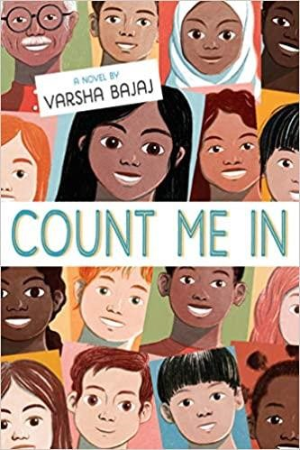 | An uplifting story, told through the alternating voices of two middle-schoolers, in which a community rallies to reject racism. Karina Chopra would have never imagined becoming friends with the boy next door--after all, they've avoided each other for years and she assumes Chris is just like the boys he hangs out with, who she labels a pack of hyenas. Then Karina's grandfather starts tutoring Chris, and she discovers he's actually a nice, funny kid. But one afternoon something unimaginable happens--the three of them are assaulted by a stranger who targets Indian-American Karina and her grandfather because of how they look. Her grandfather is gravely injured and Karina and Chris vow not to let hate win. When Karina posts a few photos related to the attack on social media, they quickly attract attention, and before long her #CountMeIn post--"What does an American look like? #immigrants #WeBelong #IamAmerican #HateHasNoHomeHere"--goes viral and a diverse population begin to add their own photos. Then, when Papa is finally on the road to recovery, Karina uses her newfound social media reach to help celebrate both his homecoming and a community coming together.  Available in print format at the Fresno County Public Library  Muaj cov ntawv luam tawm hauv Fresno County Chaw Qiv Ntawv
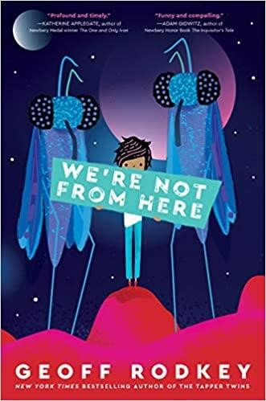 | Imagine being forced to move to a new planet where YOU are the alien! From the creator of the Tapper Twins, New York Times bestselling author Geoff Rodkey delivers a topical, sci-fi middlegrade novel that proves friendship and laughter can transcend even a galaxy of differences.  The first time I heard about Planet Choom, we'd been on Mars for almost a year. But life on the Mars station was grim, and since Earth was no longer an option (we may have blown it up), it was time to find a new home. That's how we ended up on Choom with the Zhuri. They're very smart. They also look like giant mosquitos. But that's not why it's so hard to live here. There's a lot that the Zhuri don't like: singing (just ask my sister, Ila), comedy (one joke got me sent to the principal's office), or any kind of emotion. The biggest problem, though? The Zhuri don't like us. And if humankind is going to survive, it's up to my family to change their minds. No pressure.  Available in print and ebook format at the Fresno County Public Library  Muaj cov ntawv luam tawm thiab ebook tawm ntawm Fresno County Lub Tsev Qiv Ntawv
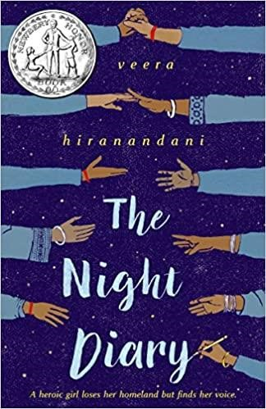 | It's 1947, and India, newly independent of British rule, has been separated into two countries: Pakistan and India. The divide has created much tension between Hindus and Muslims, and hundreds of thousands are killed crossing borders. Half-Muslim, half-Hindu twelve-year-old Nisha doesn't know where she belongs, or what her country is anymore. When Papa decides it's too dangerous to stay in what is now Pakistan, Nisha and her family become refugees and embark first by train but later on foot to reach her new home. The journey is long, difficult, and dangerous, and after losing her mother as a baby, Nisha can't imagine losing her homeland, too. But even if her country has been ripped apart, Nisha still believes in the possibility of putting herself back together. Told through Nisha's letters to her mother, The Night Diary is a heartfelt story of one girl's search for home, for her own identity...and for a hopeful future.  Available in print, ebook, and audio format at the Fresno County Public Library  Muaj cov ntawv luam tawm, ebook, thiab cov suab nyob ntawm Fresno County Public Library

