Fluency Yog Dab Tsi?
Fluency kev npliag yog qhov muaj peev xwm nyeem tau zoo thiab ncaj qha nrog qhov tseeb, qhov hais tawm, thiab qhov pom ntawm cov cim sau ntawv.
Ceev
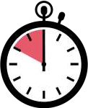

Qhov nrawm lossis ceev uas koj nyeem.
Lub hom phiaj yog los nyeem ntawm qhov “thwj xwb”. Tsis txhob nyeem nrawm dhau lossis qeeb dhau.

Kab Lus
Nyeem ntawv tau zoo ntawm cov pawg lus ua ke rau hauv cov nqe lus muaj txiaj ntsig.
Nyeem cov lus hauv tej pab pawg los yog tej nqe lus. Tsis nyeem cov lus ib.lo lus.ntawm.ib lub sijhawm.

Hais Qhia

Nyeem nrog kev xav hauv koj lub suab.
Hloov koj lub suab kom phim tus yam ntxwv. Nyeem li koj tham lus (thiab tsis zoo li ib tug neeg hlau!) Txav koj lub suab nce thiab nqis nrog cov ntawv nyeem.

Cov Cim Sau Ntawv
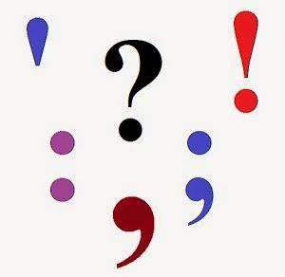

Nyeem nrog kom paub sau kom raug.
Nres ntawm tag nrho cov chaw nres. Nres ntawm qhov muaj kab quas.

Ua kom koj lub suab mus rau cov lus nug.
Kev ua kom zoo siab rau cov ntsiab lus exclamation.
Lub suab zoo li cov hais lus sib tham rau “cov cim hais”

