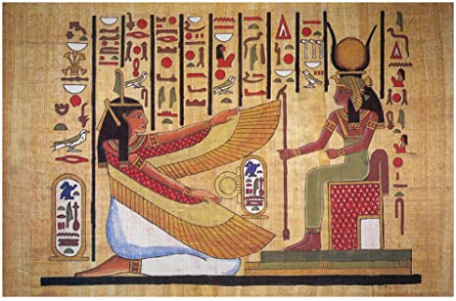
Ancient Egypt Hieroglyphic Writing
The ancient Egyptians used a form of picture writing called hieroglyphs. It took many years and the discovery of the Rosetta Stone for archeologists to translate the Egyptian hieroglyphs. Below you see a list of the hieroglyph matched with the letter it represents in our alphabet as well as what the picture symbol is (ex – the jagged horizontal line is an “N” and is water).
Introduction
Ask your child to review the Egyptian hieroglyphs by either printing this list out for them or having them view it on the computer. Tell your child that they will be using this list later to translate a text as well as to write their own name.
NOTE: If your child asks what an ankh is, you can tell them that the ankh is the symbol for “life” in Egyptian hieroglyphs. The man and woman hieroglyphs like this were used to indicate the gender of the person or as part of something only a man or woman would be doing.
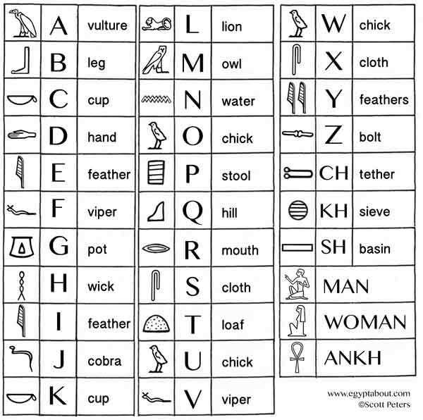
You can, if you so choose, have them check out this list of Common Egyptian Words to learn more.

Activity Options
Once your child has had a chance to look over the hieroglyph list you can have them do some of the following activities:
Option 1: Kamose Stela
  - Have your child access the following site to look at the Kamose Stela, a stone slab on which an Egyptian kept a record of his words and actions, and read its short description.
  - From there have them click on Extract 1. Your child should scroll over the hieroglyphic text from right to left to reveal what the text says.
  - Then have them lick on Extract 2 at the bottom of the page to repeat the process with a new chunk of text.
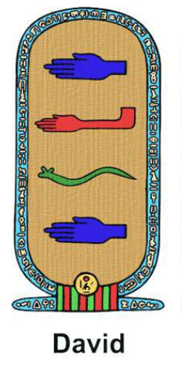
Option 2: Using the list of hieroglyphs, have your child write their name.
- If you so choose, you can print out the cartouche template on the next page for your child to write their name and then color it. For example, the cartouche to the right is for the name “David.”
