Bessie Coleman: Barnstormer
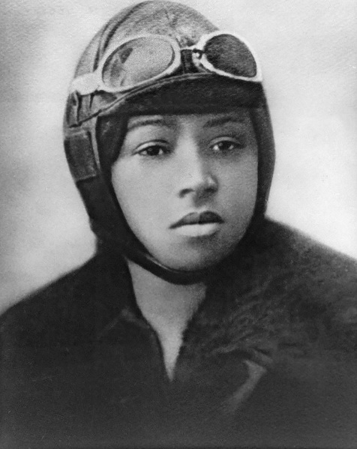
Introduction
Show your child of Bessie Coleman like the one to the right and ask them who the person is and what they think she her profession is based on the picture. Your child should be able to tell you that they think the person is a pilot based on her goggles. If you child tells you only that she is a pilot, ask them what evidence from the image made them think she is a pilot, which should prompt them to mention her goggles. Sadly, they most likely will not be able to tell you that this is Bessie Coleman as many people are unaware of her importance – the first African American female pilot.

Video Activity
Have your child watch ‘The History Guy’ Lance Geiger: Barnstorming Aviator Bessie Coleman from the History Channel’s History at Home series. As they watch the video, have them write notes about adjectives that describe Bessie Coleman and the types of tricks that she and other barnstormers performed. These notes will help your child be successful completing Activity #1 and/or Activity #2 from History at Home - Bessie Coleman Activities Sheet f you so choose to do them.

Activity Options
Activity #1 from History at Home - Bessie Coleman Activities Sheet
Give your child a sheet of paper or have them open a Word Document on their computer. Tell your child they will be making an acrostic poem about Bessie Coleman using words from the list they created while watching the video. What they choose should explain her character, personality, or achievements. (See History at Home - Bessie Coleman Activities Sheet for other details.)
Activity #2 from History at Home - Bessie Coleman Activities Sheet
Create a poster advertising a Bessie Coleman Barnstorming Show. They should include details from the video about the planes used, tricks performed, and about Bessie Coleman herself. They can also include made-up details like ticket cost for the show, date and time of the show, and location of the show. If you would like to make it more authentic to the times and to Coleman, your child could do outside research about the locations of her show and how much shows like this cost at the time. (See History at Home - Bessie Coleman Activities Sheet for other details.)

Extension Options
If you wish to extend your child’s thinking and stretch their brain a little more, consider asking them to explain what one of the following quotes means and whether they consider it a true statement and why.
- “The air is the only place free of prejudices.” – Bessie Coleman
- “Because of Bessie Coleman, we have overcome that which was worse than racial barriers. We have overcome the barriers within ourselves and dared to dream” – Lt. William J. Powell founder of the Bessie Coleman Aero Club

