Bessie Coleman: Barnstormer
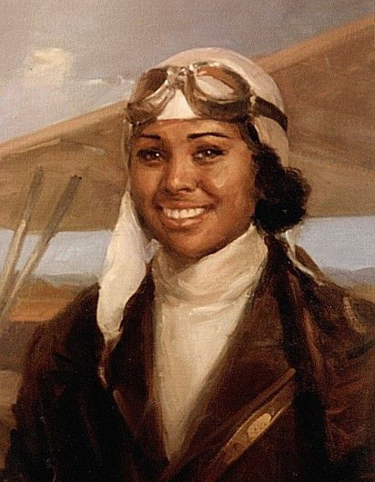
Introduction
Ask your child what they think the word “barnstorming” means. It is likely they have not heard of barnstorming before today so you might consider encouraging them to break the word into parts that they recognize – like “barn” and “storming.” From here, you might ask your child to look up the word “storming” in the dictionary or you can tell them that storming in this sense means an impressive performance showing of skill and strength.
If you choose to have your child look up the definition themself and they tell you that it is “the sudden forceful attack and capture of a building,” you can praise them for finding a different definition of storming since most people associate the word with rainstorms and thunderstorms and ask them to look at the adjective definition of the word – “(of a performance, especially in sports or music) outstandingly vigorous and impressive” – and decide which one may better describe a person. If they say the first definition, that is ok since they can revisit the definitions after the video and rethink their answer. This will help your child realize that most historians and scientists make a prediction and then either change or confirm their idea after they get more information – just like they will.

Video Activity
Have your child watch ‘The History Guy’ Lance Geiger: Barnstorming Aviator Bessie Coleman from the History Channel’s History at Home series. As they watch the video, have them think about what made Bessie Coleman an important person to learn about. If you choose to have your child complete Activity #2 from the Elementary History at Home - Bessie Coleman Activities Sheet, have your child write quick notes about the different tricks people did while barnstorming.

Activity Options
Activity #2 from Elementary History at Home - Bessie Coleman Activities Sheet
Create a poster advertising a Bessie Coleman Barnstorming Show. They should include details from the video about the planes used, tricks performed, and about Bessie Coleman herself. They can also include made-up details like ticket cost for the show, date and time of the show, and location of the show. If you would like to make it more authentic to the times and to Coleman, your child could do outside research about the locations of her show and how much shows like this cost at the time. (See History of Bessie Coleman Activities Sheet for other details.)

Activity #3 from Elementary History at Home - Bessie Coleman Activities Sheet
Have your child create different types of paper airplanes and measure the distance they fly across the room. Ask your child which airplane went the farthest and how they knew it was that airplane. They should reference the distance the paper airplane traveled as their evidence and reason why it is that paper airplane. If your child has already learned how to create a bar graph, you can ask them to create one showing the different distances traveled by the different planes. Your child can then reference the bar graph in their explanation as to why a certain model of paper airplane went farthest.
If you would like to extend your child’s learning into the sciences, you can encourage your child to do more research into what makes an airplane fly, which they can then add to their explanation.

